A
PROJECT REPORT ON

Farmers Marketplace
An Online Food Merchandise Store

SUBMITTED IN PARTIAL
FULFILLMENT OF
DIPLOMA IN ADVANCED COMPUTING (PG-DAC)

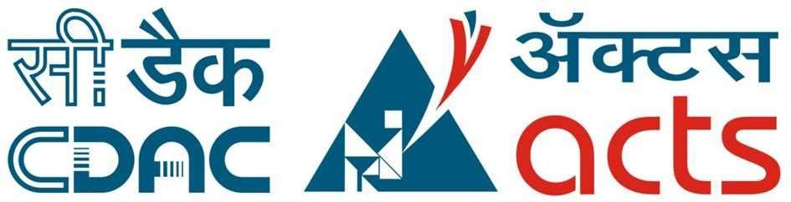

UNDER THE GUIDANCE OF Mr. Nilesh shirke
: PRESENTED BY :
230940420071 | Saurabh Shahaji Jadhav
230940420069 | Satya Prakash dutt
230940420063 | Ganesh Pandurang Shelke
230940420052 | Suyog Dhavdekar

AT
CENTER FOR DEVELOPMENT OF ADVANCED COMPUTING C-DAC,
MET IIT MUMBAI,MAHARASTRA

ACKNOWLEDGEMENT

The project “Farmers Market Place” was a great learning experience for us and we are submitting this work to Advanced Computing Training School (C-DAC MET IIT MUMBAI,MAHARASTRA).
We are very glad to mention the name of Mr. Nilesh shirke for her valuable guidance to work on this project.
We are highly grateful to Mr. Nilesh shirke., Manager of C-DAC MET IIT MUMBAI,MAHARASTRA Training Centre, for his guidance and support whenever necessary during the course of our journey to acquire PGDiploma in Advanced Computing (PG-DAC) through CDAC MET IIT MUMBAI.
Our heartfelt thanks go to Mr. Junaid (Lab Coordinator, PG_DAC) who gave us all the required support and kind coordination to provide all the necessities to complete the project and throughout the course up to the last day of the course.
We would like to express our sincere gratitude towards Mr. Rahul Barve, our faculty for J2SE and J2EE, who was always there for us. Her guidance and support throughout the course helped us to overcome various obstacles and intricacies during the course of our project work. Without her tremendous support, guidance, and efforts, this project would not have been possible.
:FROM:
230940420071 | Saurabh Shahaji Jadhav
230940420069 | Satya Prakash dutt
230940420063 | Ganesh Pandurang Shelke
230940420052 | Suyog Dhavdekar

TABLE OF CONTENTS
1. | INTRODUCTION
2. | PRODUCT OVERVIEW AND SUMMARY
2.1. Purpose
2.2. Scope
2.3. Overview
2.4. Feasibility Study
3. | REQUIREMENTS FULFILLED
3.1. Functional Requirements
3.2. Non-Functional Requirements
4. | PROJECT DESIGN
4.1. Data Model
4.2. Functional Decomposition Diagram
4.3. Use Case Diagram
4.4. Activity Diagram
4.5. Project Architecture
4.6. ER Diagram
5. | PROJECT SCREENSHOTS
5.1. Customer
5.2. Admin

- TESTING
- CONCLUSION
- FUTURE SCOPE
- REFERENCES

ABSTRACT

The Business to Consumer Model has come a long way ever since it time of inception. While it has expanded into multiple types of goods, there is still a section of market that remains untapped: Fresh goods. As the current generation of consumers is becoming more and more health conscious, and with current trends of organic food, Fresh foods can become the next big thing in e-commerce.
This project deals with developing an e-commerce website for online fresh foods product sale. It provides list of farmers that offer fresh fruits and vegetables, and products page for each farmer’s offerings. It also provides a cart for ease of remembering the choices selected by user. The user can also view their order history to go back to the farmer from whom they purchased the last batch of products.
Two main technologies were used in this project: Java and React. Java was used for backend. React is used for client side rendering of the page, which offloads the load of rendering views to the client, and provides a fluid single page experience. MySQL has been used as database to store list of users, farmers and their products.
This project has been designed and implemented in multilevel architecture so as to have minimum coupling and maximum cohesion.

1 .INTRODUCTION
Fresh produce industries across the world are facing a roller-coaster ride of new developments and trends. Although there might be a few tight turns and steep slopes, the latest trends paint an inspirational picture of what lies ahead in the next five to 10 years.
In the fresh produce sector, technology and retail innovations abound. From futuristic hi-tech grocery stores, the rise of e-commerce opportunities, culinary innovation centers and revolutionary robotics technology to vertical farming and plant-based food innovations like cauliflower pizza and vegetable steaks.
Online Shopping of Fresh Food opens up a new world of options. Users won’t have to go from store to store to hunt for fresh food. They won’t have to worry about wondering whether their food is organic or inorganic. They will be able to refill their fridges in just one click, all while sitting at home.
Our system offers one stop solution to all fresh food needs. Users can log into their accounts and then they will be taken to produces offered by the farmer.
Customer can pick what foods they want to order and add to the cart. Once they are done selecting what they require, after reviewing cart summary they can simply click on check out button to pay bill and they will get an order details pdf on their registered email for the same. Their cart will be delivered to their houses.
This can be done from any place, at any time all from the internet, thus making it easy to get your daily need of fresh foods.

2. PRODUCT OVERVIEW AND SUMMARY

2.1. PURPOSE
The Farmer’s Marketplace, as the name Suggested is about farmers and their showcased merchandise. It is about connecting farmers directly to the customers, thereby cutting the middle man. This ensure that customers get fresh foods at a very cheap price. This also ensure that all the farmers get a fair chance at gaining customers so that they don’t have to rely on any middle man.

2.2. SCOPE
“Farmers Market Place” aims to deliver a web-based application that hosts a wide collection of the food-items that users can browse through. Users can place orders and make payment. They can update their profile, add delivery address .They can view their order history as well.
Admins can manage various product details like stock, price, adding new products, and categories etc. Only admin can add farmers. Admins can even delete users and/or farmers, if the need arises.
This project does not support the actual logistics and delivery of food items and actual payment logic. We are assuming that the organization that implements it will be using third-party payment API which can easily be integrated in our application if needed. Farmers Market Place is only an interface for both customers (for browsing and shopping for food items) and admins (for managing products, farmers, users listing).

2.3. OVERVIEW

A.TECHNOLOGIES USED
i. FRONT END
- HTML
- CSS
- JavaScript
- React
- Axios
- BACK END
  - Spring Boot
  - Spring Data JPA
  - Hibernate

- DATABASE MANAGEMENT SYSTEM
  - MySQL

B. FEATURES PROVIDED

i. FOR ADMINS
- Login & Logout – Similar to customers, admins can login & logout to access their account.
- Add / Update Farmers –Only admin is responsible for adding and updating the details of farmer.
- Delete Farmer –The admins can delete a farmer account if they need to for any purpose.
- Add New Category – Admins can add category.
- Delete Category – Admins can remove category.
- Add New Products – Admin can add new product with details as stock, price, name, quantity, image, category, etc.
- Manage Products– Admin can update the product details.
- View Users – Admin can view all registered users.
- Delete User – Admin can delete a user if need arises.
- View order details – Admin can view order details for all users.

ii. FOR CUSTOMERS

- Browse – Customers can browse the homepage to explore the entire products available.
- Register, Login & Logout – New customers can register on the site. Existing customers can then login to access their account information and logout when the account is not in use.
- View & Update Profile – When logged in, customers can view their profile and update their details.
- Update Delivery Address – When purchasing listed items, a customer can update delivery addresses which they can associate with their account.
- Add to Cart & Place Orders – If customers finds the food item of their choice they can save the item in the cart until they decide to purchase it.If at any point they want to cancel certain item they can simply remove it from the cart on one click. When they wish to purchase it, they can place orders for those items by selecting a delivery address on their account and pay the bill.
- View Order History – Every customer can view their order history in order to get an idea about their past spending. Also the customer will get email notification for respective order details.

2.4. FEASIBILITY STUDY
Feasibility is the determination of whether a project is worth undertaking or not. Before actually recommending the new system, it is important to investigate if it is feasible to develop it.
Before developing and implementing a system, we have to make sure that the system is feasible in the following ways:
- TECHNICAL FEASIBILITY:
In this type of feasibility study, the system analyst has to check whether it is possible or not to develop the requested system with the available manpower, software, hardware, etc.

This project makes use of cross-platform software and solutions like Java, and hence can run on any operating system. React, used in front-end, is swift and light weight framework when it comes to delivering the requested page as it doesn’t reload the entire page for every HTTP request. It only re-renders the components that need to fetch new data. Also, as React is modular in nature, it is easy to develop new components and scale up existing components in order to add new features to the system. The combination of Spring Boot, Spring Data JPA and Hibernate for backend make for a fast, easy to set-up and reliable system to interact with the database, as they are secure and transactional in nature. Since the sensitive data of customers and admins need to be stored in a robust and secure database, MySQL database management system was chosen as it is an industry standard.

- OPERATIONAL FEASIBILITY

In this type of feasibility study, the operation of the system is considered. An analysis is performed on whether it is feasible for the user department to use the application. Thus, the proposed system is said to be operationally feasible only if clients are able to understand the system clearly and correctly, and can use it with ease.
In the design of this project, we always kept user experience in mind. We made an effort to have a good user interface with consistent theme and alluring design to keep the users interested and engaged. In our project, the use of universally known icons and instructions that are easy to understand makes sure that the user will not need any special technical know-how to use the application. We made sure that the information available throughout the application is arranged in a logically coherent and consistent manner, guaranteeing that the users will have a smooth and effortless experience and even enjoy using the application.

- ECONOMICAL FEASIBILITY:

In this type of feasibility study, the benefits of the system to the organization are considered by taking into consideration the cost-benefit analysis. All the software and technologies used in our project free, open-source, and widely available, with each of the technologies having an extensive community support. This makes “Farmers Market Place” an economically feasible solution to the organizations that wish to implement it.

3. REQUIREMENTS FULFILLED

3.1. FUNCTIONAL REQUIREMENTS
Following are the functional requirements fulfilled by our project:
- Similar to customers, admins can login & logout to access their account.
- Only admin is responsible for adding and updating the details of farmer.
- The admins can delete a farmer account if they need to, for any purpose.
- Admins can add and remove category.
- Admin can add new product with details as stock, price, name, quantity, image, category and update and remove them.
- Admin can view all registered users, delete a user if need arises
- Admin can view order details for all users.
- Customers can browse the homepage to explore the entire products available.
- When logged in, customers can view their profile and update their details.
- If customers finds the food item of their choice they can save the item in the cart until they decide to purchase it. If at any point they want to cancel certain item they can simply remove it from the cart on one click. When they wish to purchase it, they can place orders for those items by selecting a delivery address on their account and pay the bill.
- Every customer can view their order history in order to get an idea about their past spending. Also the customer will get email notification for respective order details.

3.2. NON-FUNCTIONAL REQUIREMENTS
Following are the non-functional requirements fulfilled by our project:
- Since the application uses lightweight and established software components that are also cross-platform, it is remarkably performant and has good support for every operating system.
- The use of React for front end and Spring Boot, Spring Data JPA and Hibernate for back end delivers quick response times to admins and customers alike.
- Card-style UI and well-known icons and symbols used throughout the application provides a consistent theme and user-friendly interface that anyone can grasp easily, even without a technical background.

4. PROJECT DESIGN

4.1. DATA MODEL
The following tables depict the database design used for “Wordsworth” application:

A. Tables Related to User Details
- Users Table
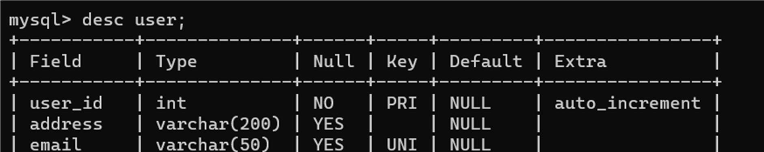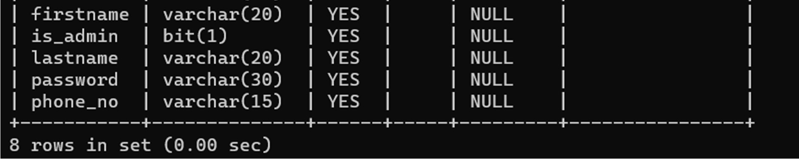
- Farmers Table
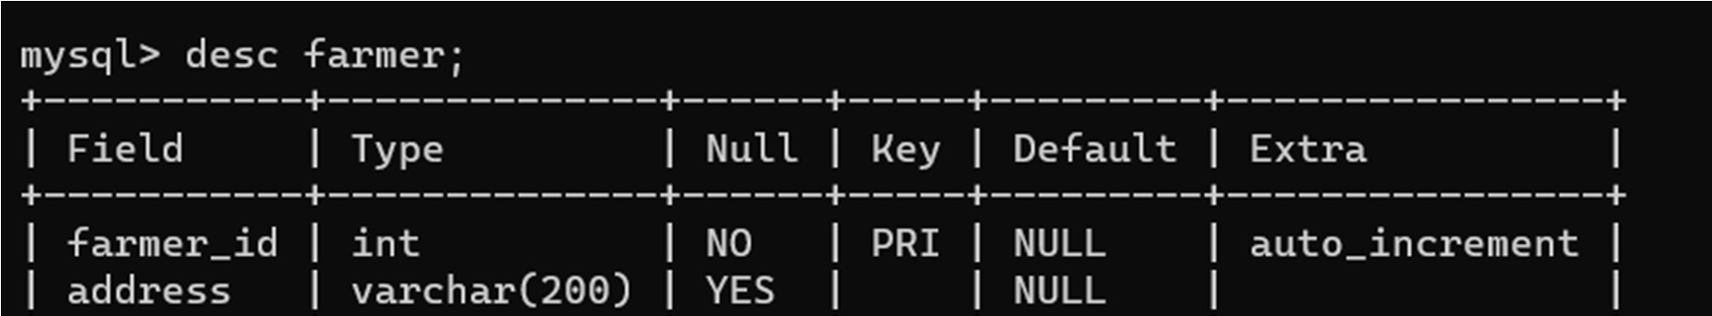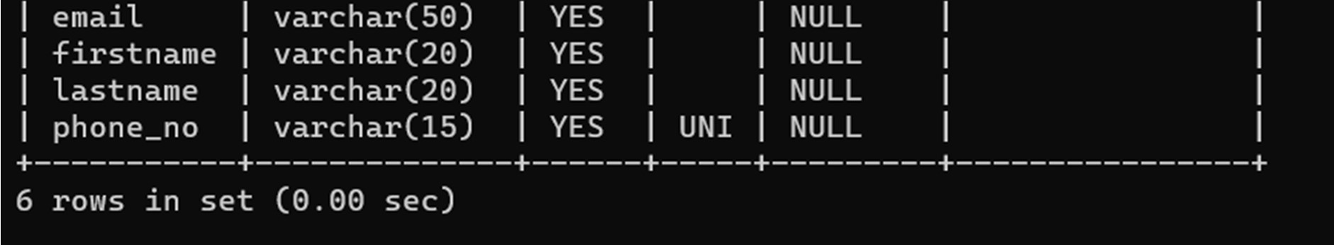

B. Tables Related to Orders
  - Stock Details Table
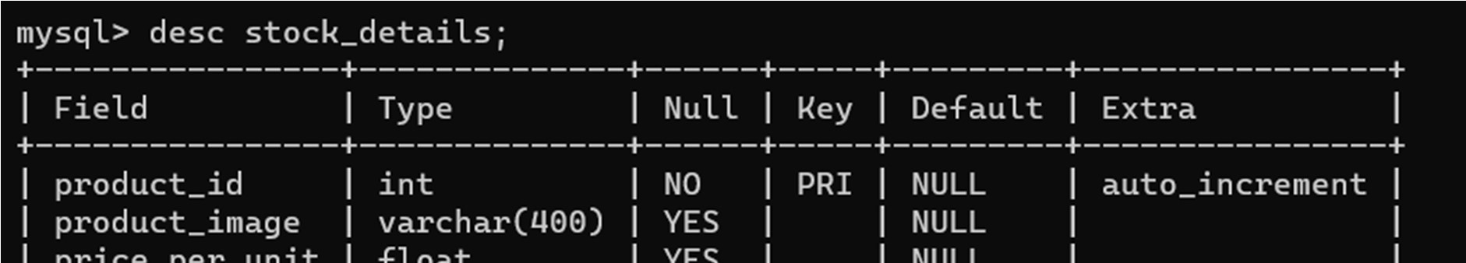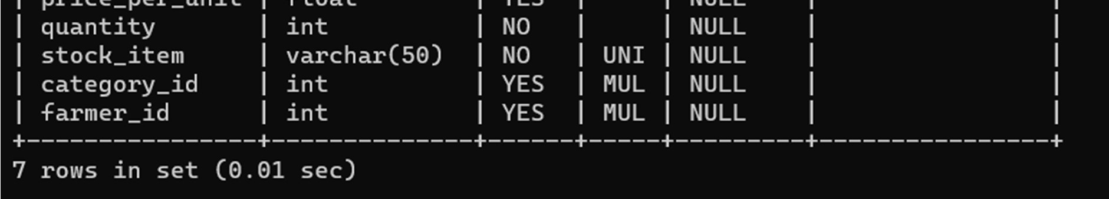

  - Orders Table
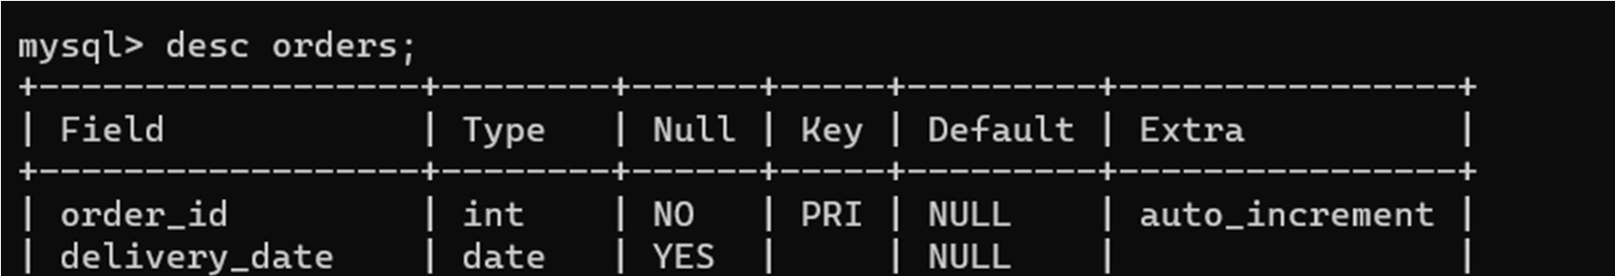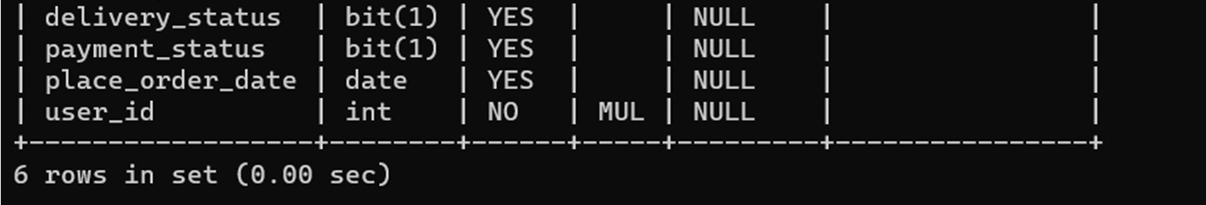

  - Order Details Table
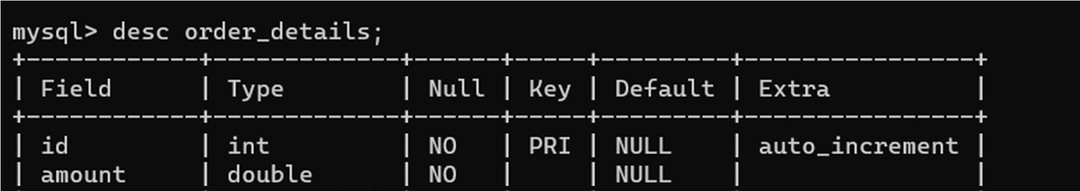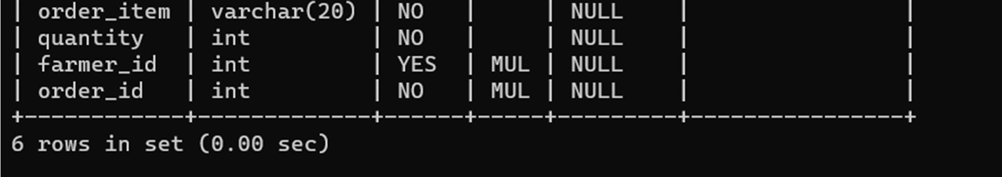

  - Category Table
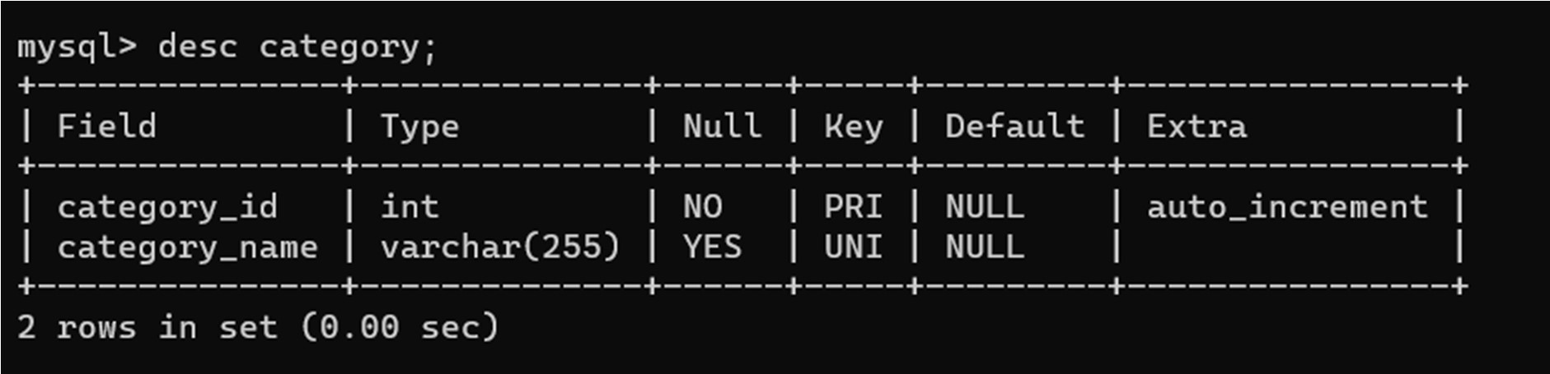

4.2. FUNCTIONAL DECOMPOSITION DIAGRAM

    - Admin Side DFD
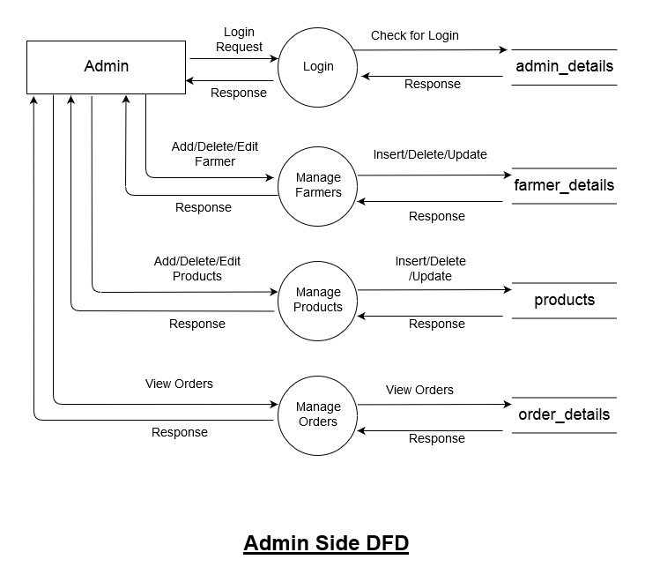

    - User Side DFD
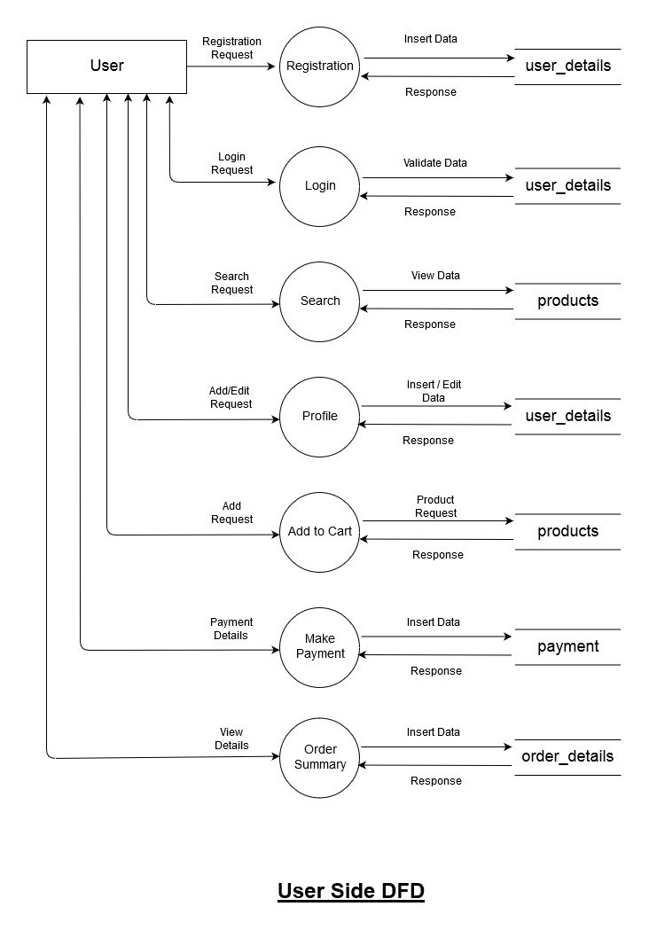

4.3. USE CASE DIAGRAM

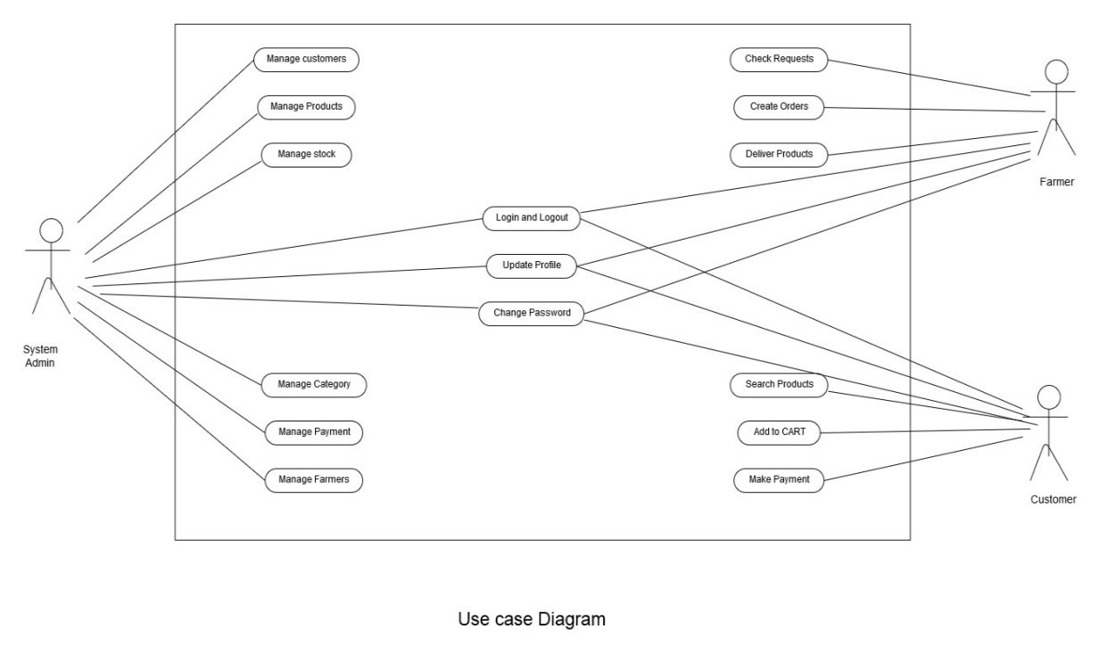

4.4. ACTIVITY DIAGRAM
    - User

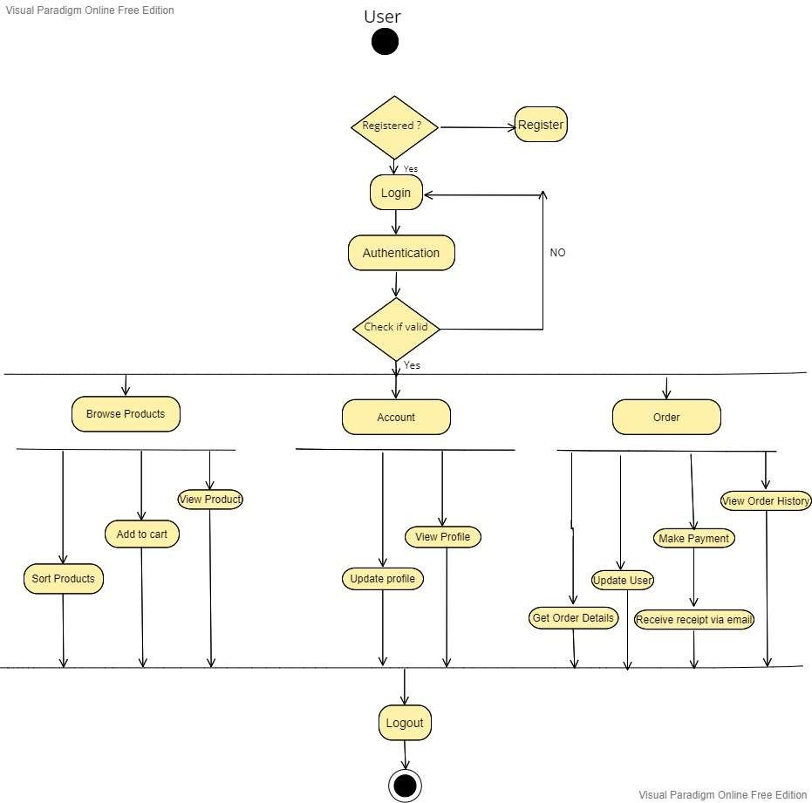

    - Admin

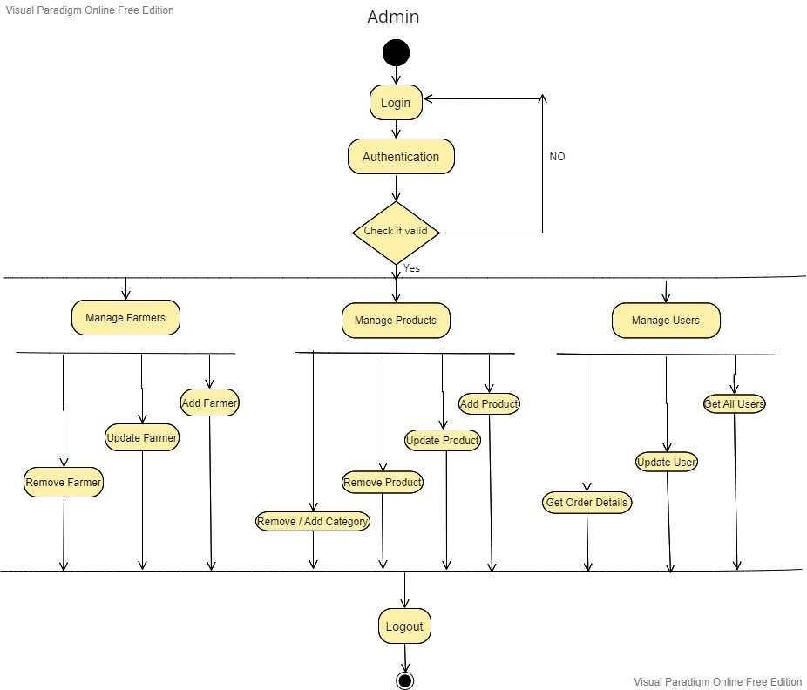

4.5. PROJECT ARCHITECTURE

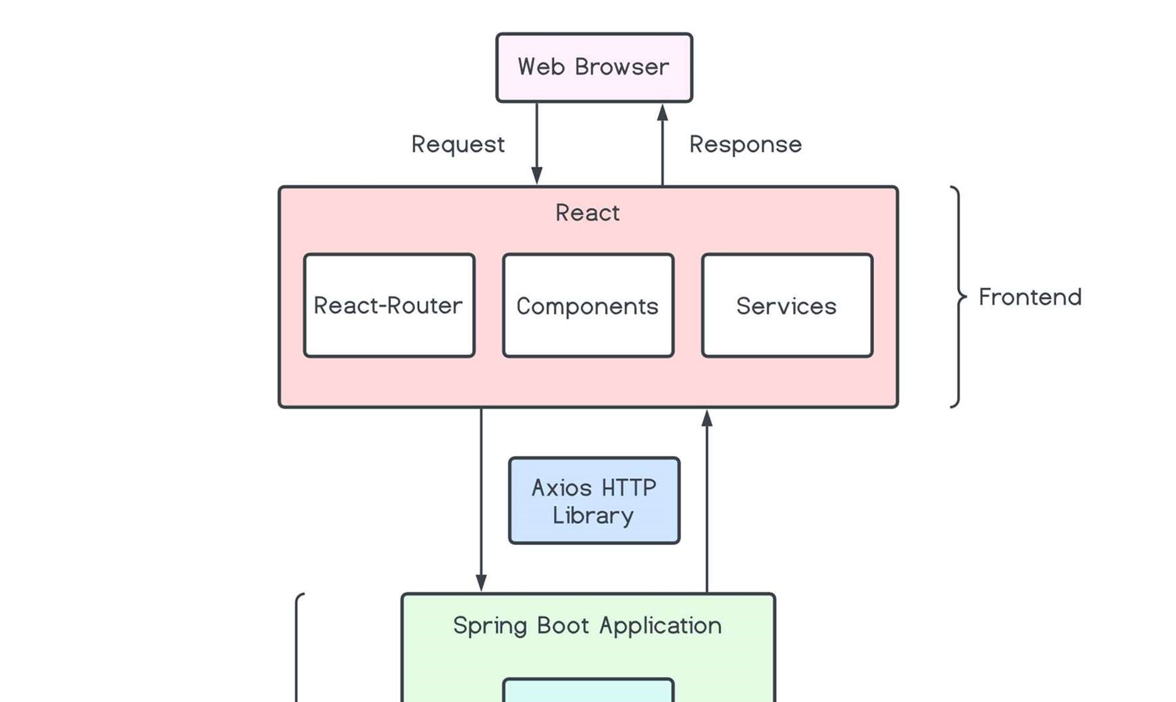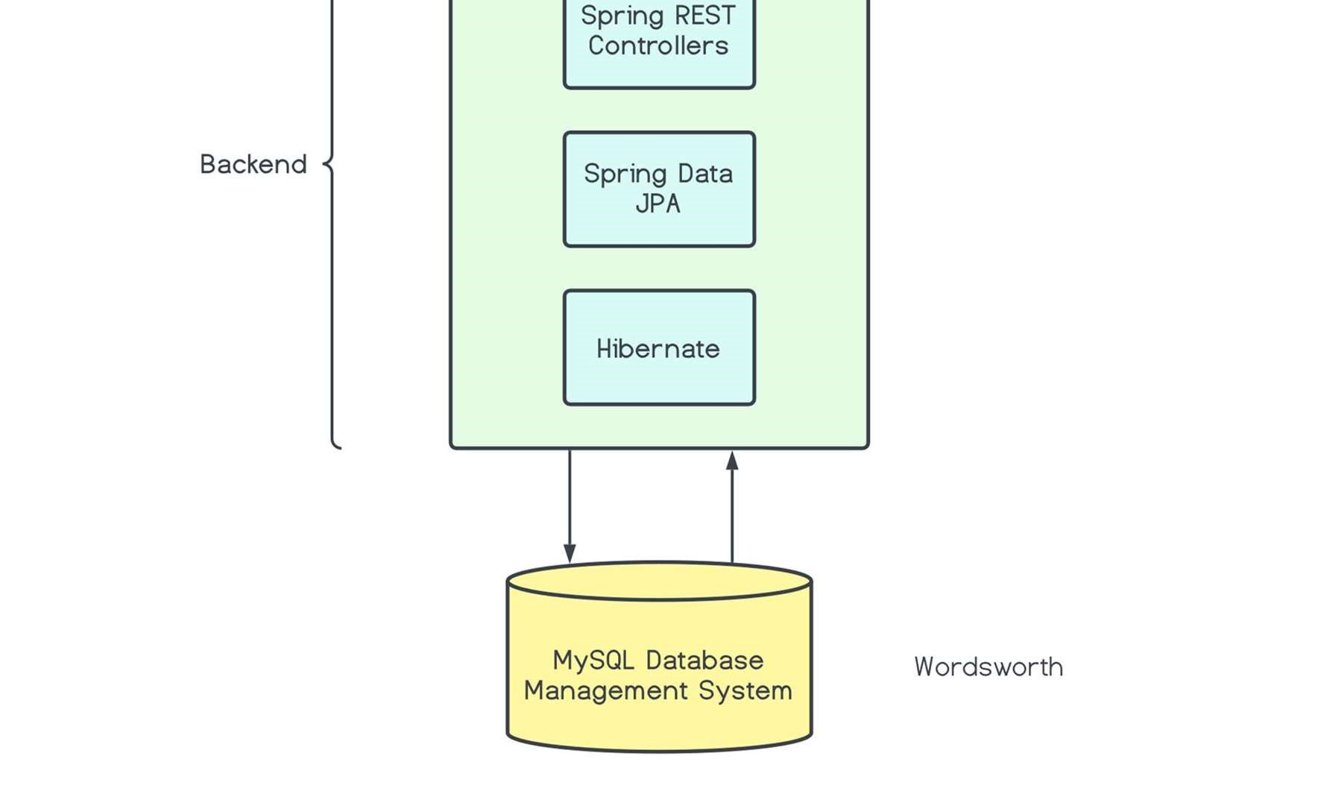

4.6. ER DIAGRAM

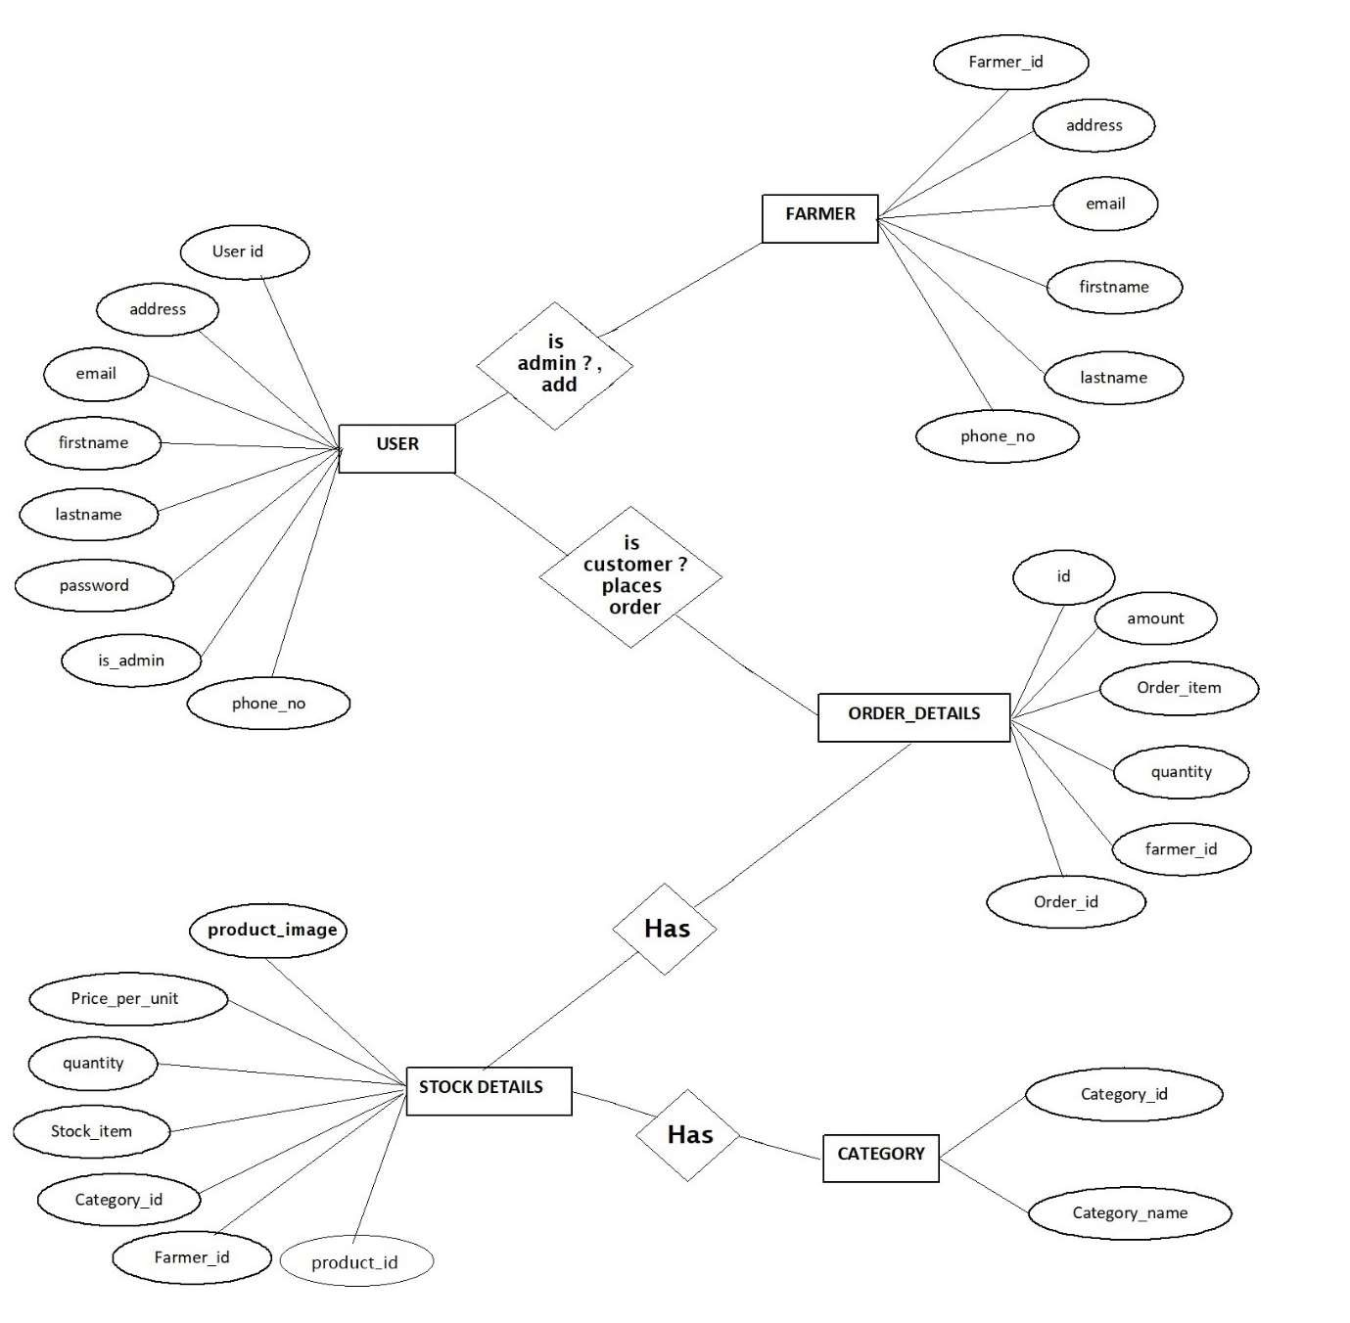

5. PROJECT SCREENSHOTS

5.1. USER
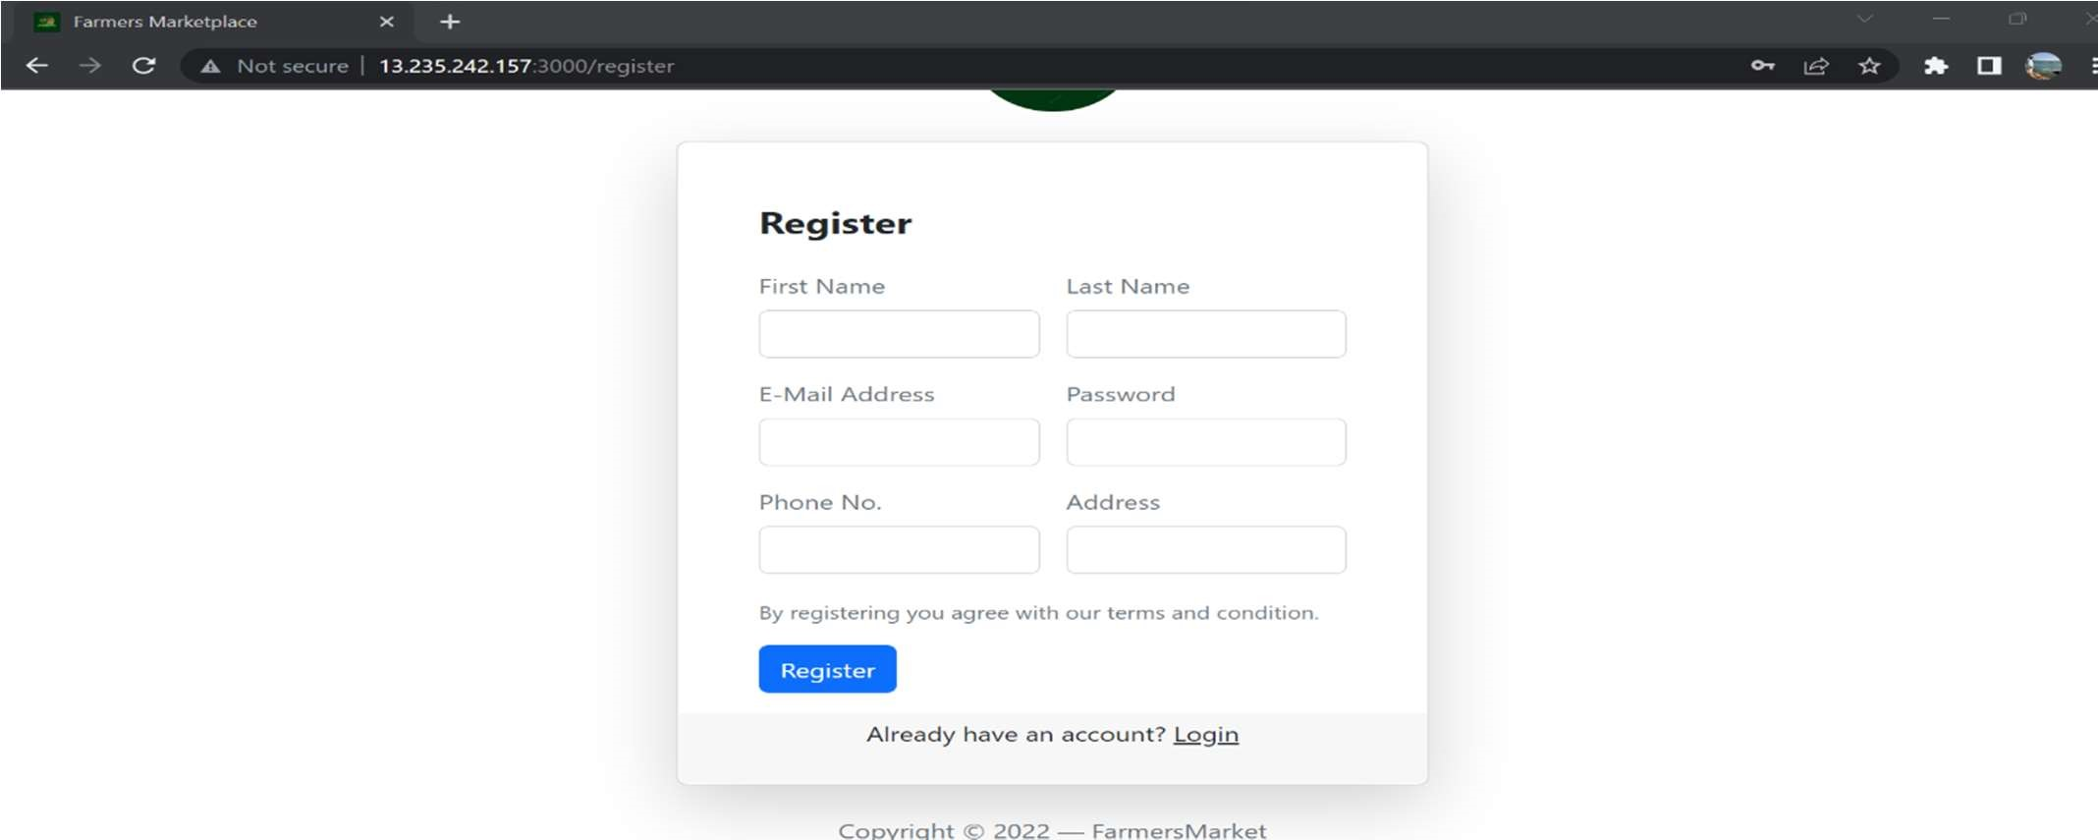

Register
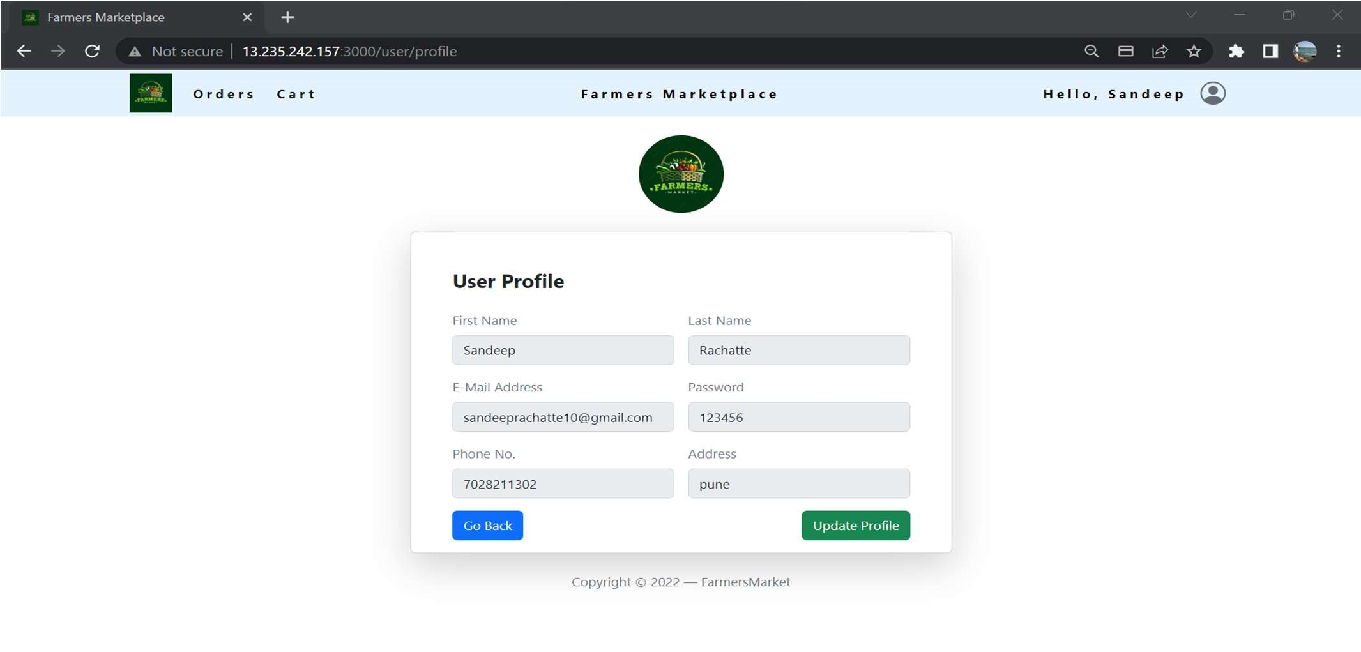
Login

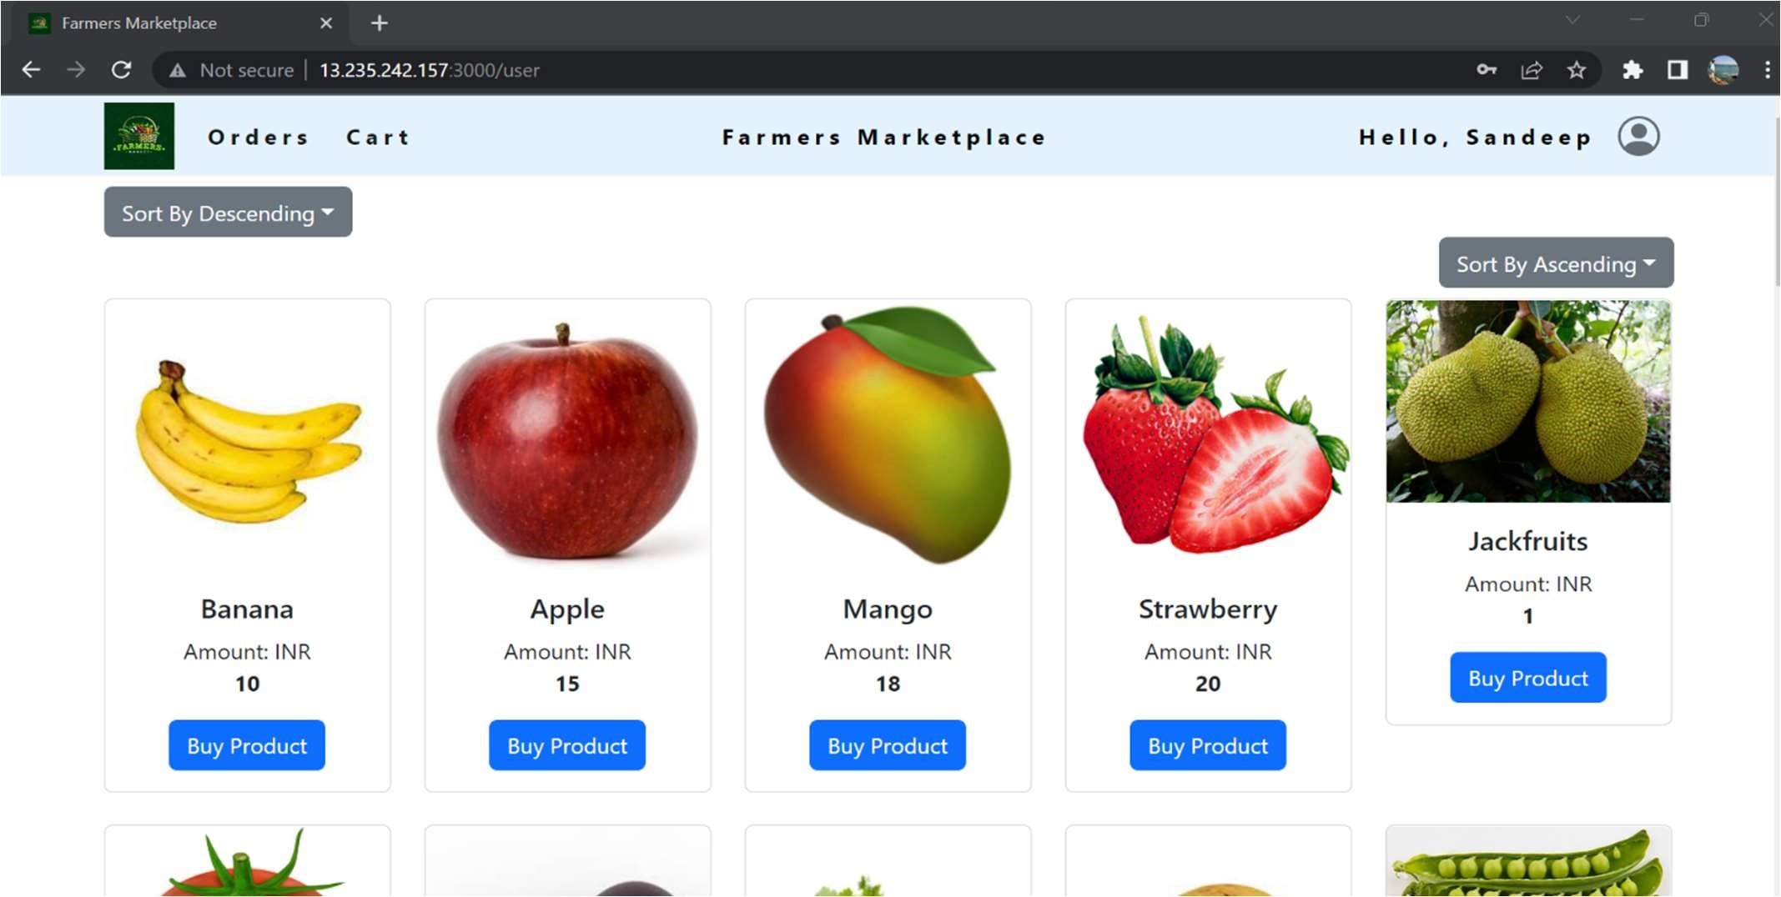
Home Page

User Profile
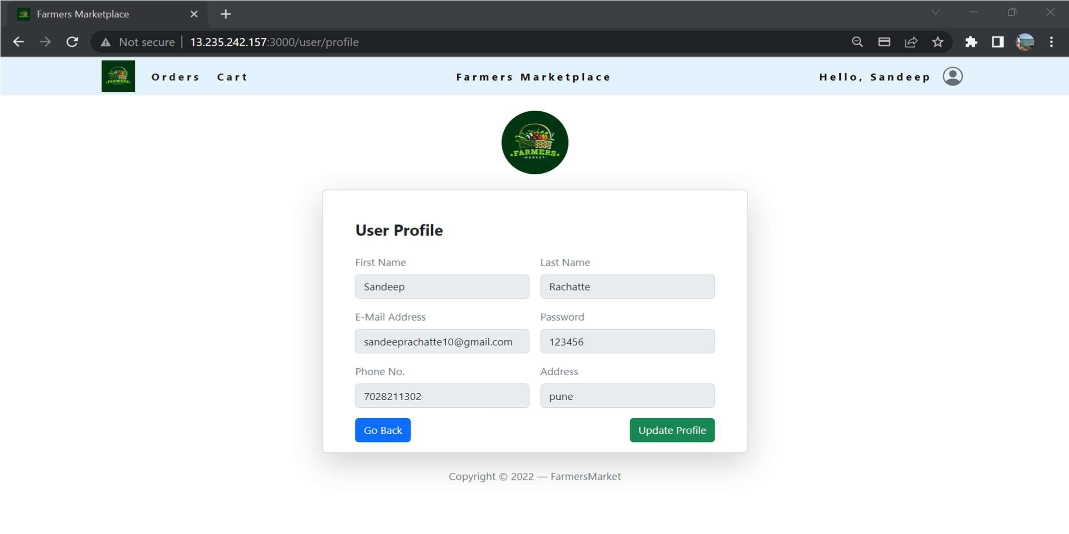

User Cart

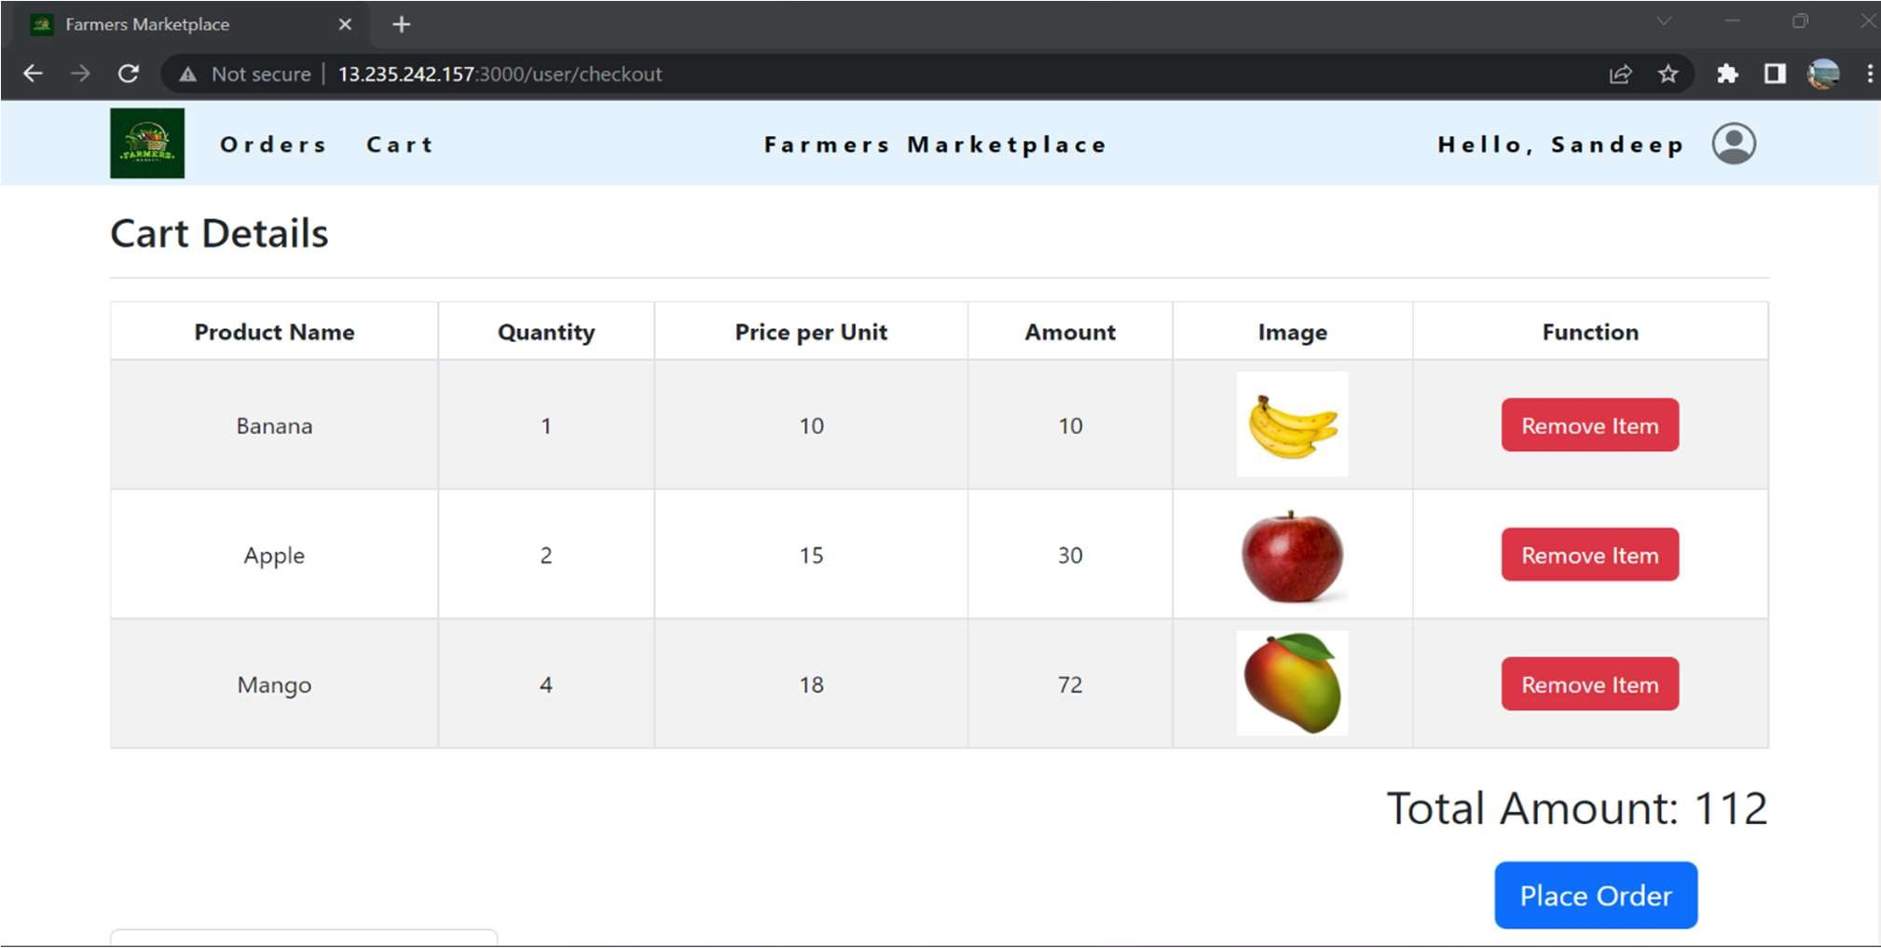

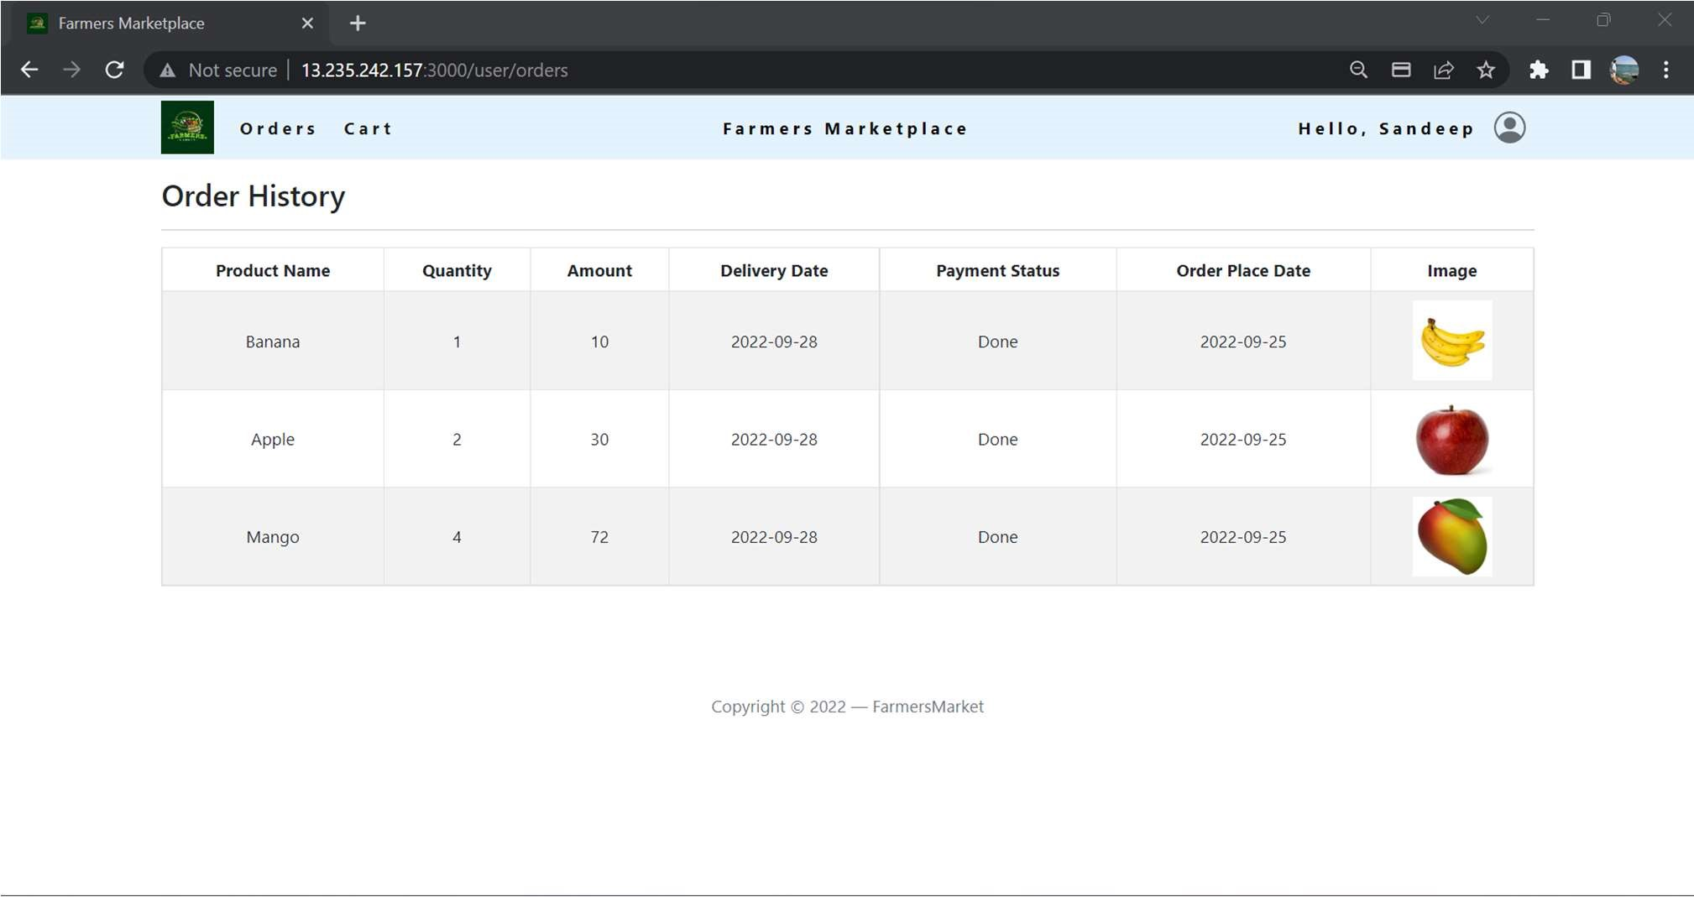
Order History

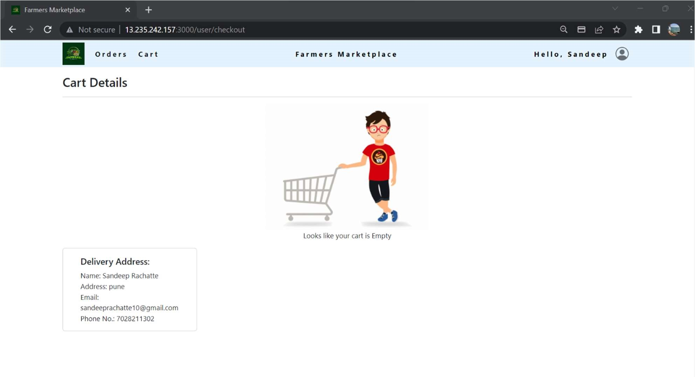
Empty Cart

Sort Products
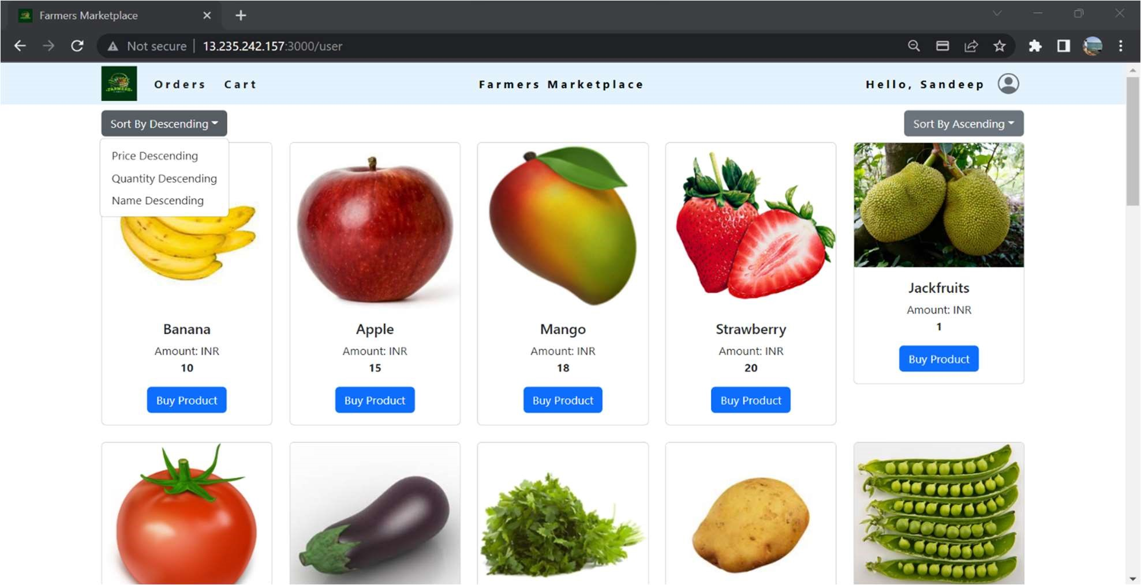

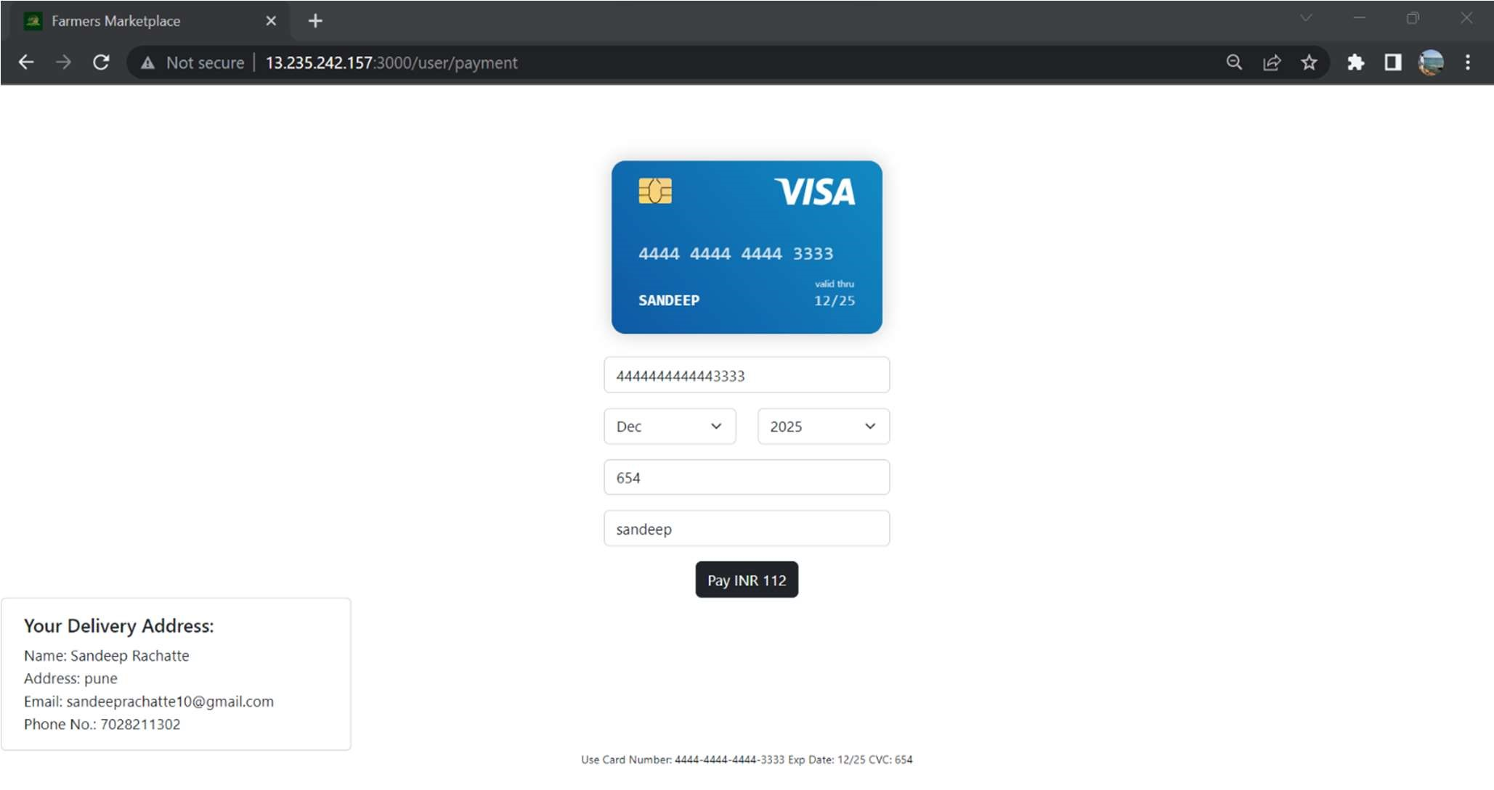
Payment Gateway

5.2. ADMIN
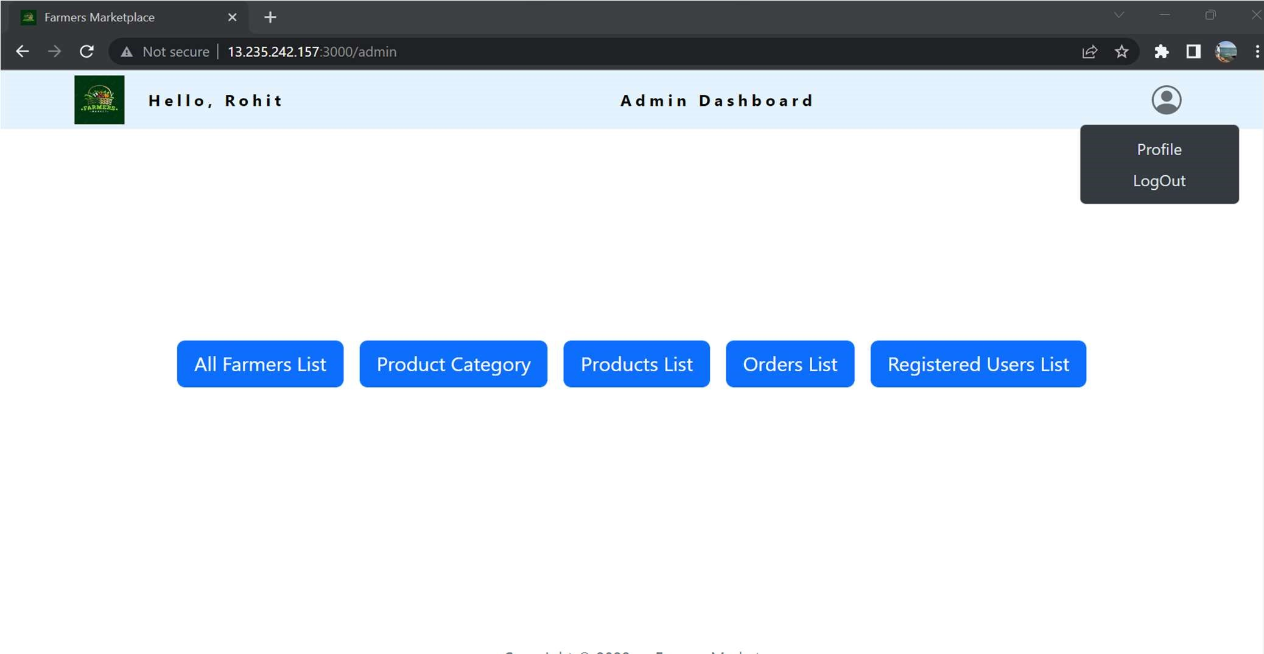
Admin Dashboard

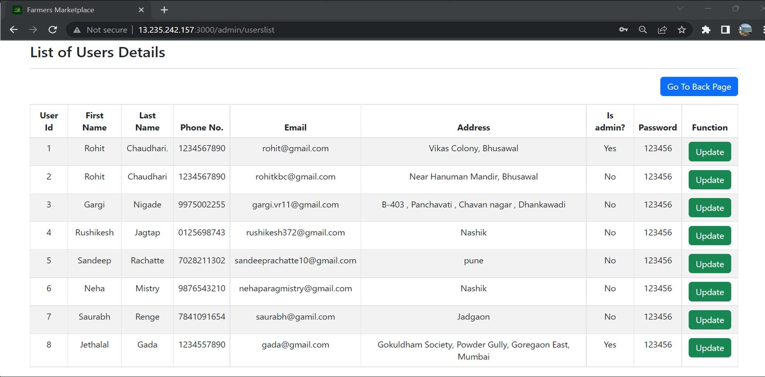
View All Users

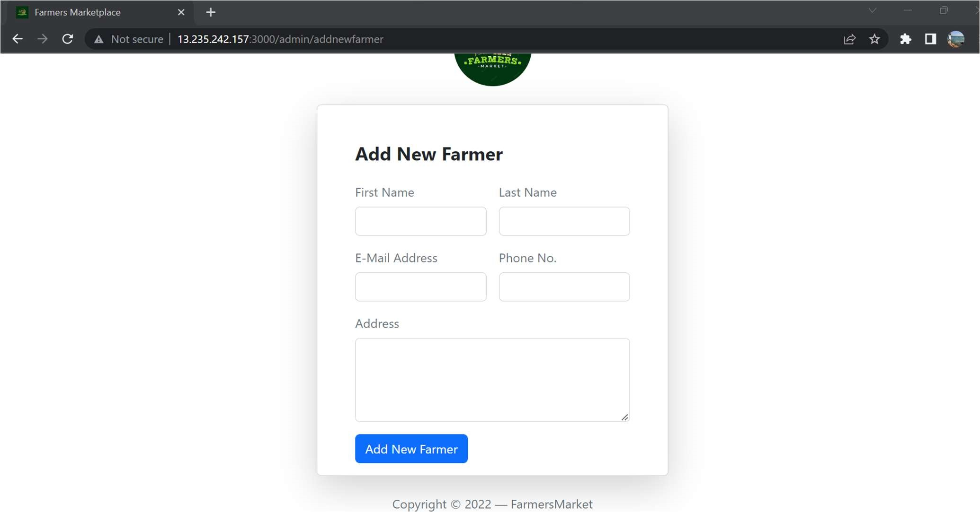
Add New Farmer

Admin Profile
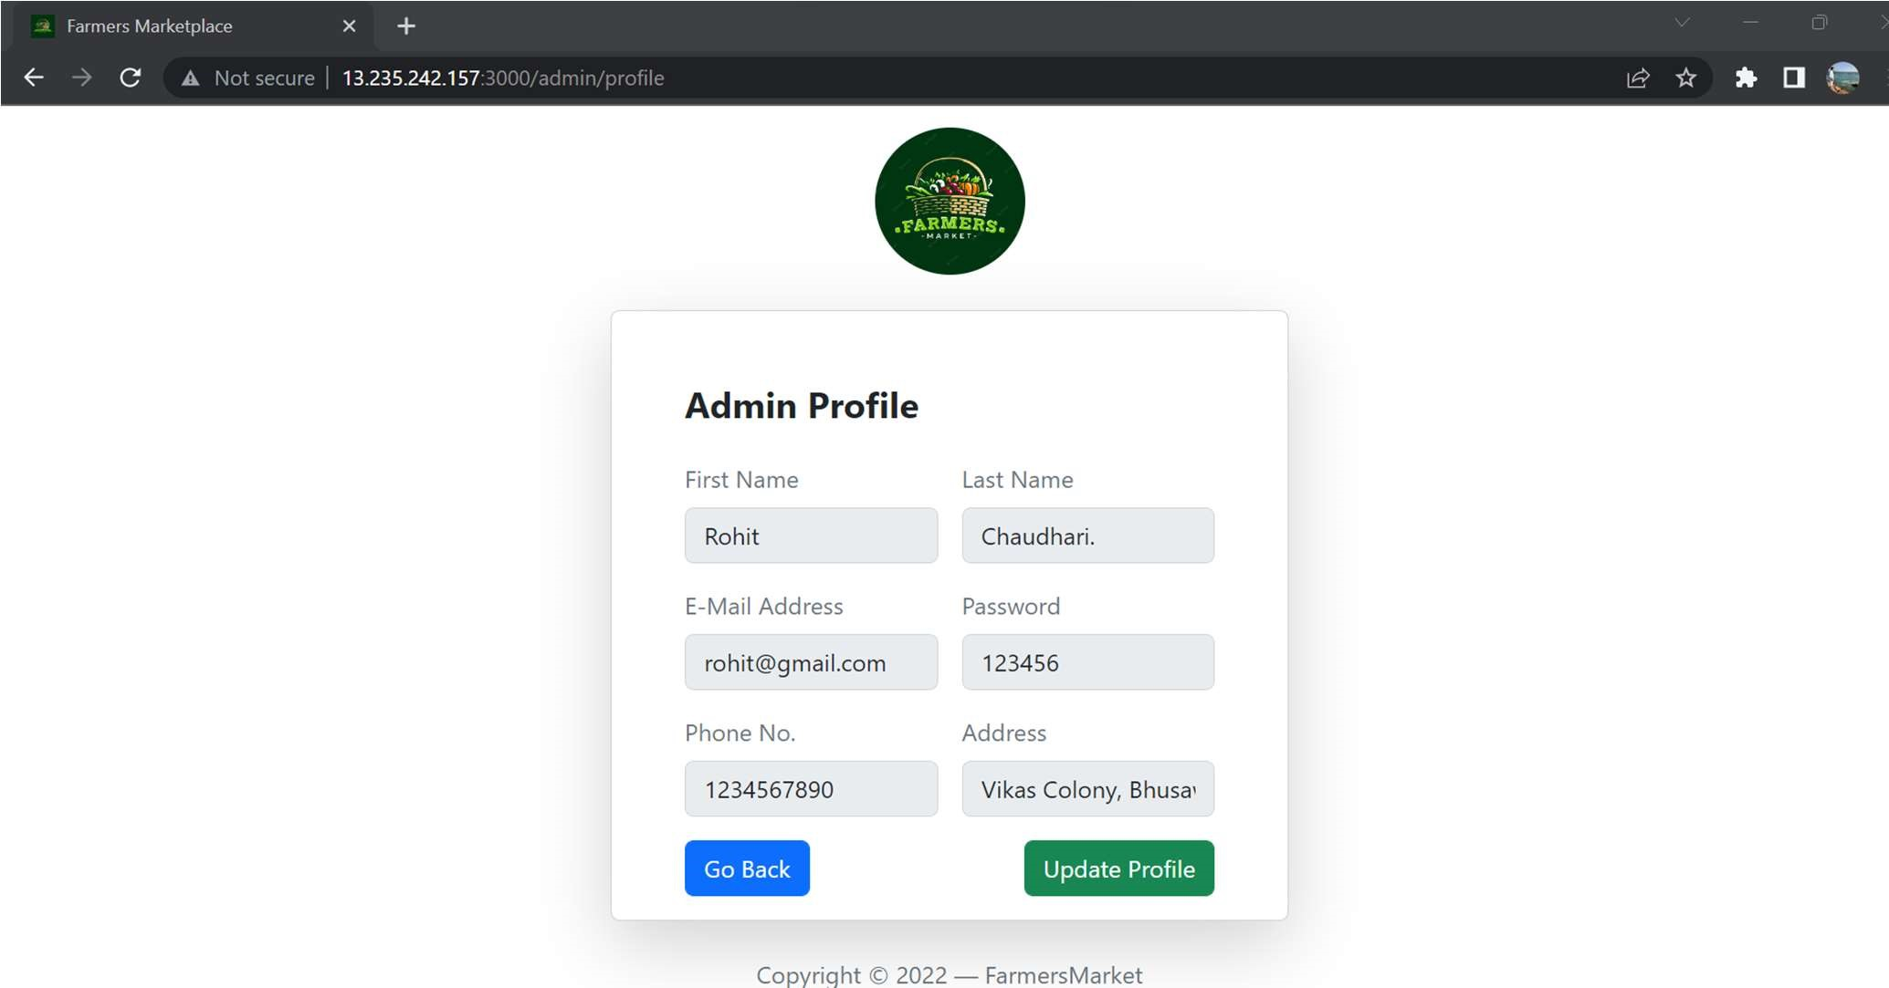

List of Farmers
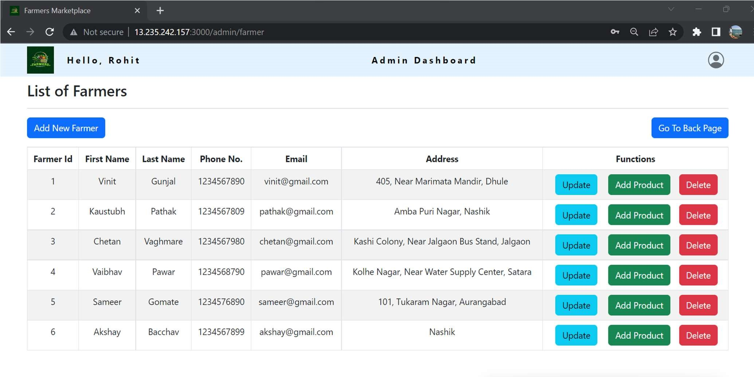

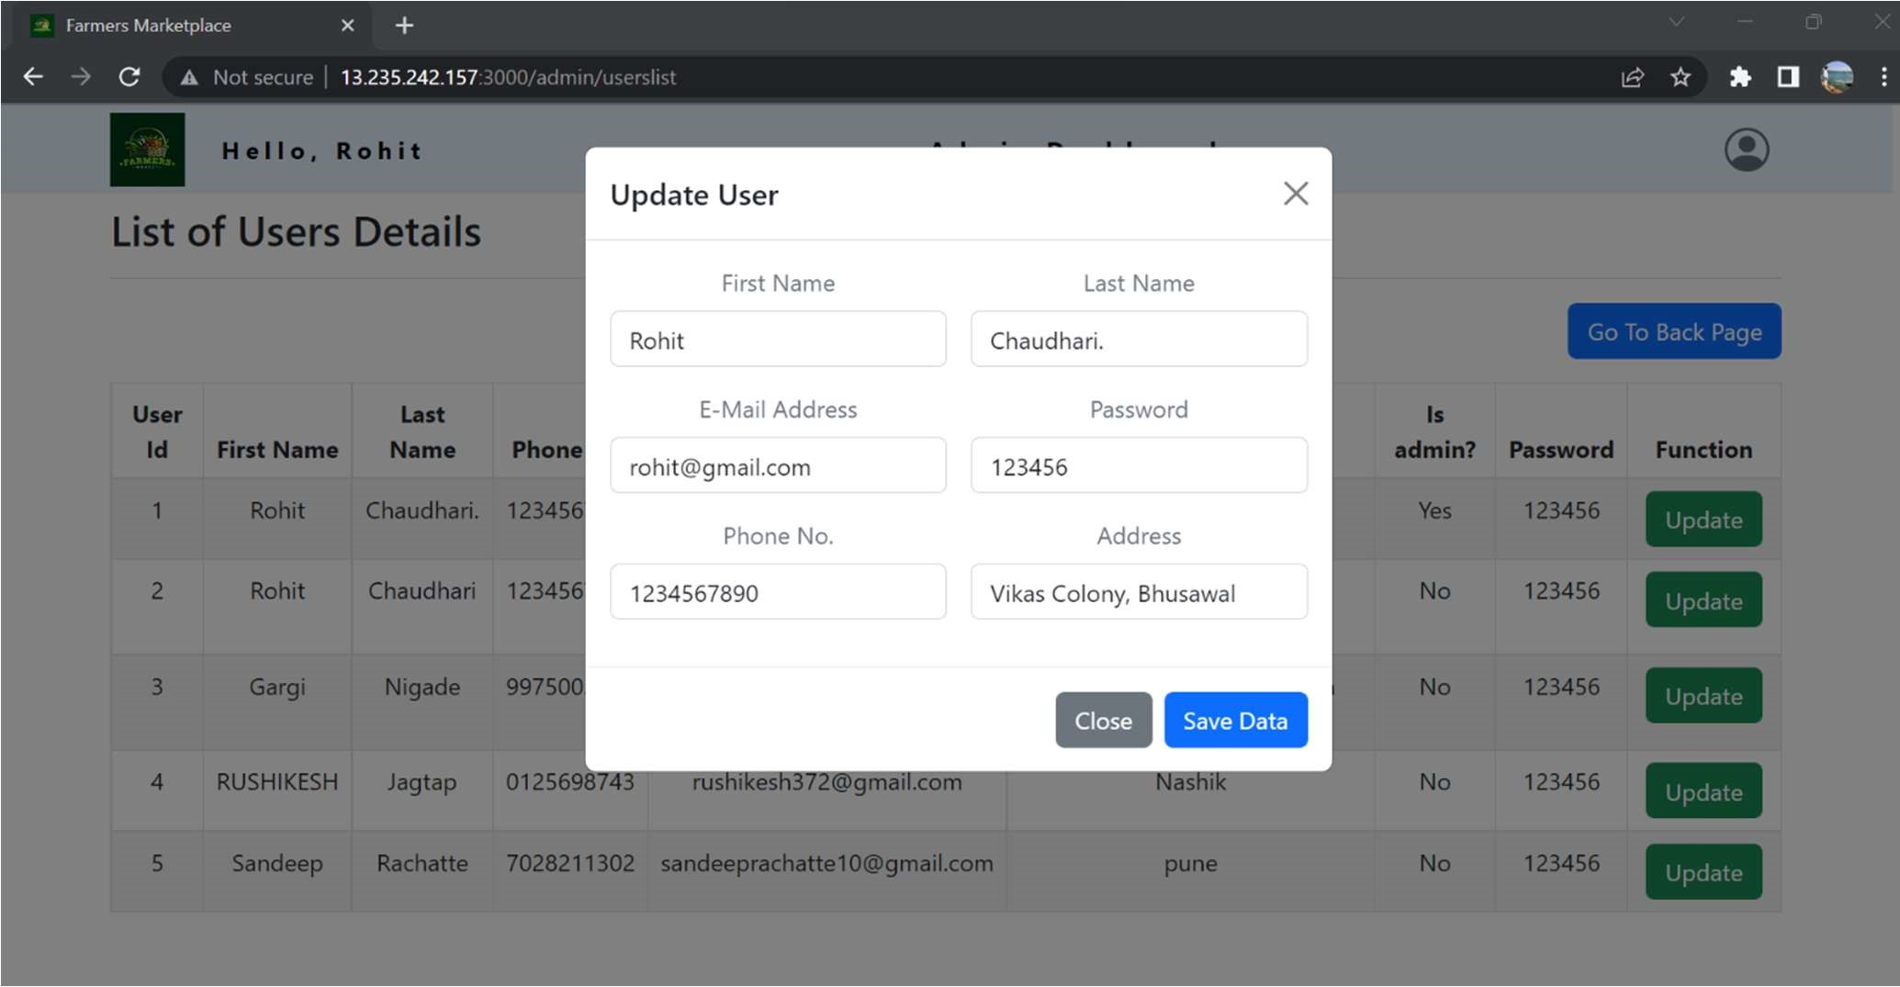
Update User Details

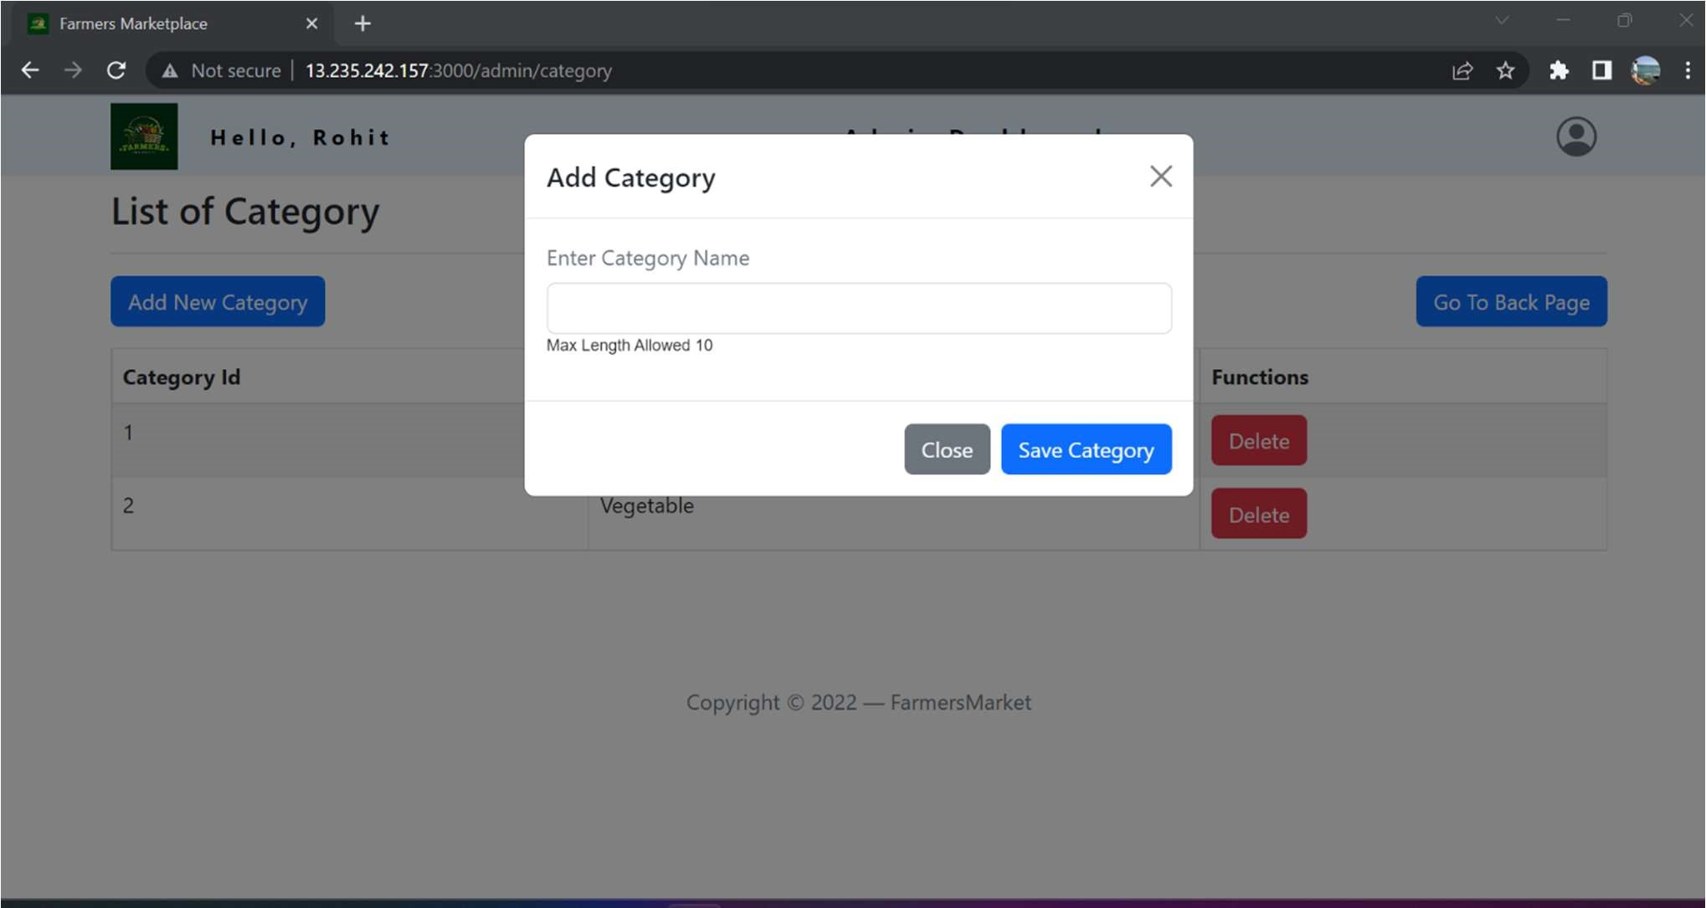
Add Category

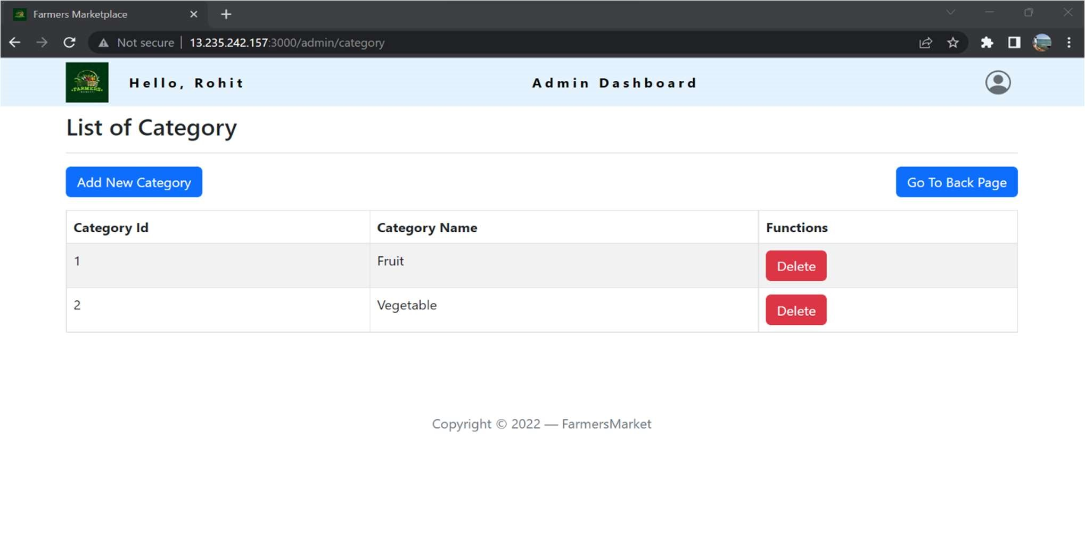
List of Category

List of Products
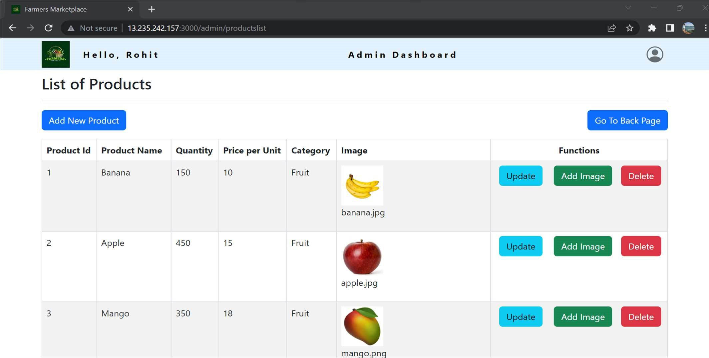

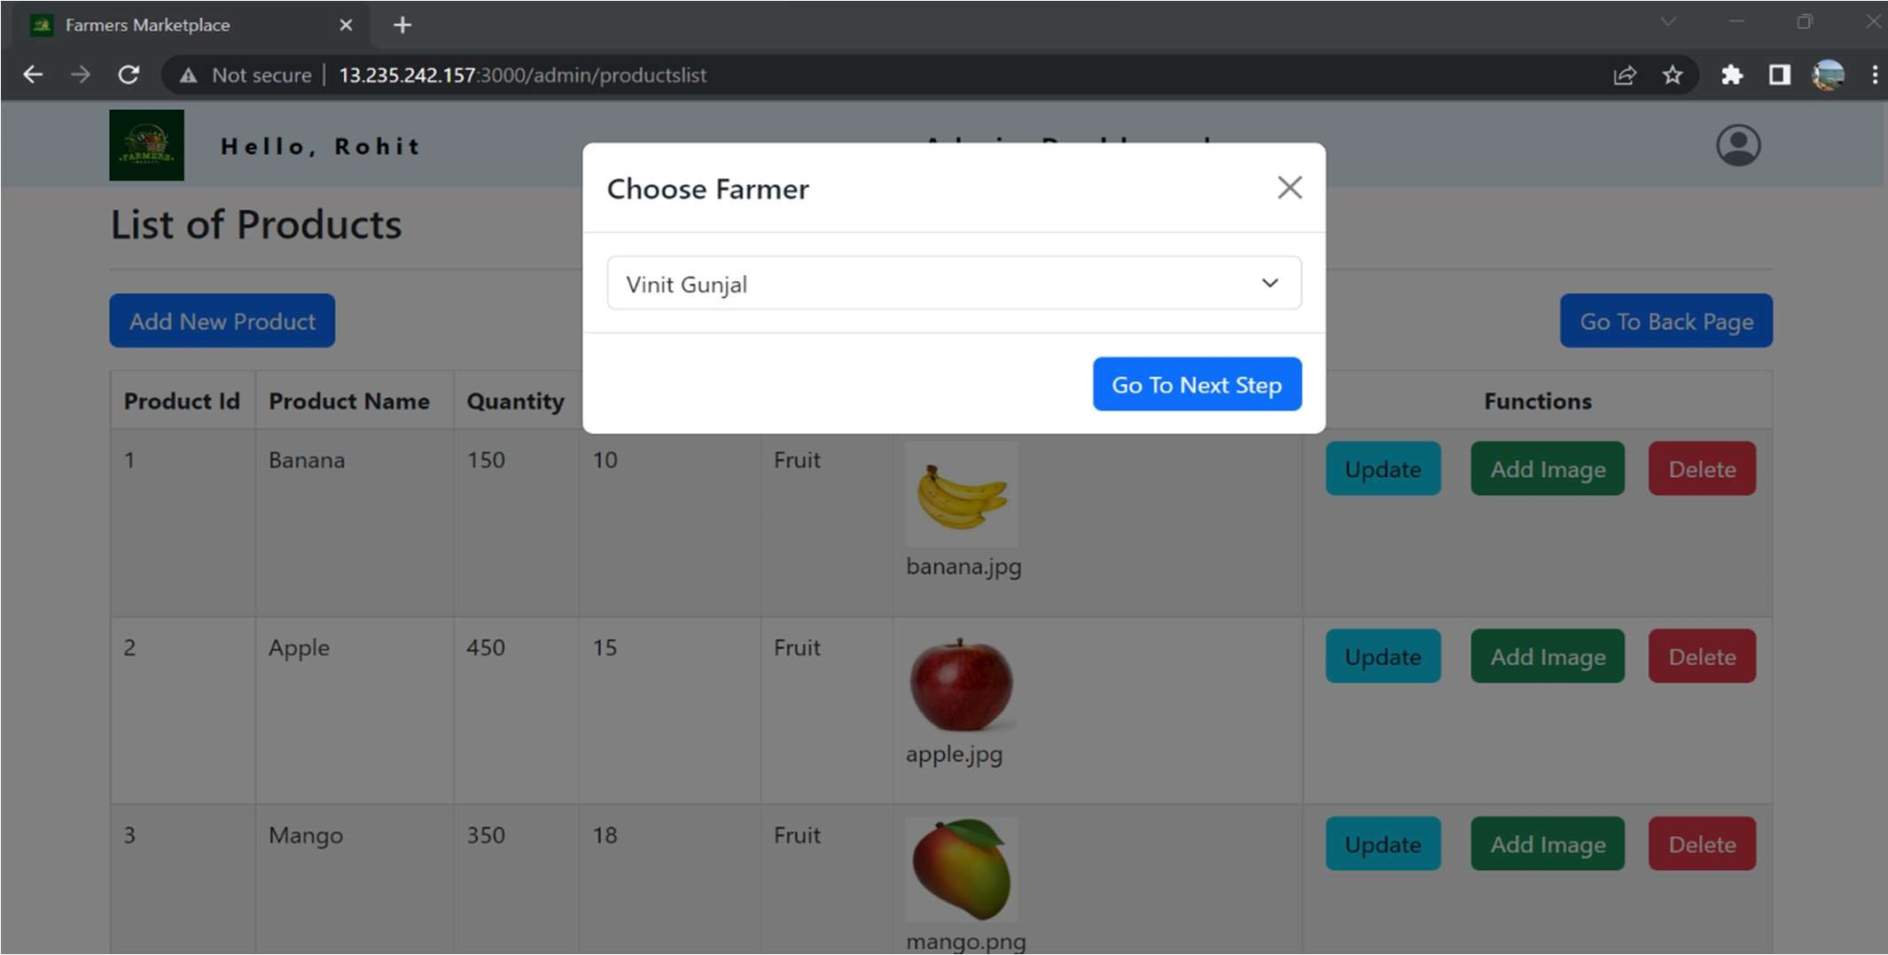
Add New Product

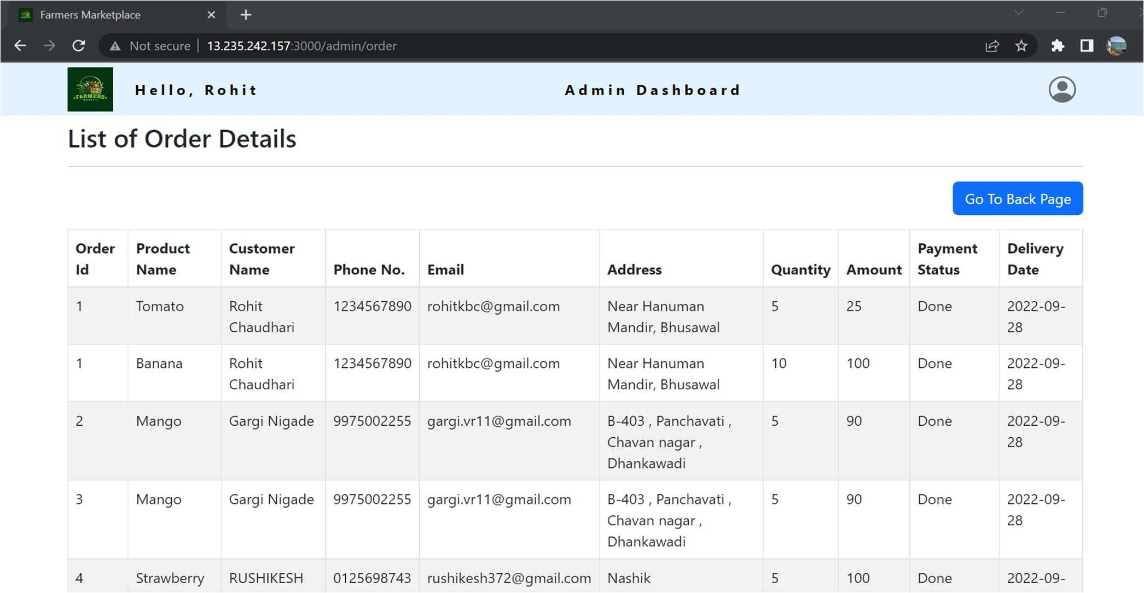
Order Details

6. TESTING
One of the main purposes of testing is to validate and verify that the system works as intended. No program or system design is perfect. However, if we implement the system without proper testing, then it may cause problems and lead to a bad user experience.
Testing and checking outcomes of each test gives us the best chance to detect and correct errors before the system is implemented in a production environment.
In the course of our project, we made an effort to manually test each component. In all cases, we obtained the desired results as demonstrated below.

A. CUSTOMER FEATURES TEST

# | Description | Outcome | Result
1  . | Register as Customer | New customer details saved in the database. | Passed
2  . | Login as Customer | Fetched authenticated user details saved in database. | Passed
3 | Browse Products | Fetched list of all products from the database. | Passed
4 | Add Food items to Cart | The product along with necessary details were saved in database in the customer’s cart. | Passed
5 | Place Order | The cart items associated with the customer were saved in the form of a placed order in the database. | Passed
6 | View Order History | The past orders made by the customer were fetched from the database. | Passed
7 | Update User Profile | The profile information updates/ modifications get reflected in Database | Passed
8 | Logout | The session was cleared. | Passed

B. ADMIN FEATURES TEST

# | Description | Outcome | Result
1. | Sign in as Admin | Fetched authenticated user details saved in database. | Passed
2. | Add New Farmers | The Farmer details along with all their related details were added to database. | Passed
3. | Update/ Delete Farmers | The Farmer details along with all their related details were updated to database. | Passed
4. | Add New Product Category | New product-category gets added to database. | Passed
5. | Add New Product Item | New item and all its respective details saved in database. | Passed
4. | Manage Product stock | The stock of the product was updated in the database. | Passed
5. | Update/Delete Product Details | The details of an existing product were updated/deleted in the database. | Passed
6. | View Customer List | All Customers details are fetched from the database. | Passed
7. | Update/Delete Customer Details | The details of an existing Customer updated/deleted in the database. | Passed
8. | View order details | All Orders placed by all customer are fetched from the database. | Passed
9. | Logout | The session was cleared. | Passed

7. CONCLUSION

“Farmers Market Place”, an online Grocery store application, was developed by our project team to simplify the online sale and purchase of Fresh-organic merchandise.
We tried using the latest technologies that are cross-platform and robust. Each and every software we used was open-source in nature, which keeps the cost of production at a minimum.
We were also meticulous about the user experience aspect of our application so that navigating our website is an easy and seamless experience.
In conclusion, “Farmers Market Place” is an application would definitely be a good choice for any fresh-food merchandise trading Farmers that wishes to enter the online market. At the same time, it provides one-stop platform for Customers to purchase their daily need of merchandise directly from authenticated Farmers.
We are confident that the numerous features and visually appealing look of application will certainly give a big boost to the Farmers.

8. FUTURE SCOPE

Using whatever we have learnt over the duration of this course, we tried to make our project as user-friendly and gave it as many features as possible in the limited time allotted for the project work. That said, there are certainly more features that can be added to our application. Some of those are mentioned below:
- The most purchased and/or sponsored products can be highlighted as customer favourites to promote merchandise further.
- Rating chart for Farmers and Products.
- Product Display based on Categories, distributing Farmers and respective ratings.
- Discounts can be given on a per-user basis depending on the customer’s purchase history as well as how many products they buy at the same time.
- Customers can upvote/downvote/report feedbacks.
- Additional payment means can be added other than cards.
- In case the user forgets the password, a ‘reset password’ functionality can be added.
- CAPTCHA can be added to login page.

9. REFERENCES
Following is the list of websites we referred during the course of our project:
i. https://getbootstrap.com/docs/5.1/getting-started/introduction/ ii. https://reactjs.org/docs/getting-started.html iii. https://www.baeldung.com/ iv. https://www.w3schools.com/
- https://docs.spring.io/spring- data/jpa/docs/current/reference/html/#reference
- https://javaee.github.io/javaee-spec/javadocs/ vii. https://javadoc.io/doc/org.springframework.data/ index.html
viii. https://github.com/amaroteam/react-credit-cards

